**BLOCK-CHAIN BASED CERTIFICATE VALIDATION**

## A PROJECT REPORT

***Submitted by,***

**Vrushank Rao -20201CSE0857**

**Vinay Kumar M -20201CSE0856**

**K C Sri Venkatesh -20201CSE0885**

### *Under the guidance of,*

**Dr. Pamela Vinitha Eric**

***in partial fulfillment for the award of the degree of***

**BACHELOR OF TECHNOLOGY**

**IN**

**COMPUTER SCIENCE AND ENGINEERING**

**At**



**PRESIDENCY UNIVERSITY**

**BENGALURU**

**JANUARY 2024**

**PRESIDENCY UNIVERSITY**

**SCHOOL OF COMPUTER SCIENCE ENGINEERING**

**CERTIFICATE**

This is to certify that the Project report **“BLOCK-CHAIN BASED CERTIFICATE VALIDATION”** being submitted by “Vrushank Rao, Vinay Kumar M, KC Sri Venkatesh” bearing roll number(s) “20201CSE0857, 20201CSE0856, 20201CSE0885” in partial fulfillment of requirement for the award of degree of Bachelor of Technology in Computer Science and Engineering is a bonafide work carried out under my supervision.

|  |  |
| --- | --- |
| **Dr. Pamela Vinitha Eric**  Professor  School of CSE&IS  Presidency University | **Dr. Pallavi**  Professor & HoD  School of CSE&IS  Presidency University |

|  |  |  |
| --- | --- | --- |
| **Dr. C. KALAIARASAN**  Associate Dean  School of CSE&IS  Presidency University | **Dr. SHAKKEERA L**  Associate Dean  School of CSE&IS  Presidency University | **Dr. SAMEERUDDIN KHAN** Dean  School of CSE&IS  Presidency University |

**PRESIDENCY UNIVERSITY**

**SCHOOL OF COMPUTER SCIENCE ENGINEERING**

**DECLARATION**

We hereby declare that the work, which is being presented in the project report entitled **BLOCK-CHAIN BASED CERTIFICATE VALIDATION** in partial fulfillment for the award of Degree of **Bachelor of Technology** in **Computer Science and Engineering**, is a record of our investigations carried under the guidance of **Dr**. **Pamela Vinitha Eric, Professor,** **School of Computer Science Engineering, Presidency University, Bengaluru.**

We have not submitted the matter presented in this report anywhere for the award of any other Degree.

|  |  |  |
| --- | --- | --- |
| **NAME** | **ROLL NUMBER** | **SIGNATURE OF THE STUDENT** |
| **VRUSHANK RAO** | **20201CSE0857** |  |
| **VINAY KUMAR M** | **20201CSE0856** |  |
| **K C SRI VENKATESH** | **20201CSE0885** |  |

|  |  |
| --- | --- |
|  |  |

**ABSTRACT**

Education is crucial for individuals, and with students acquiring numerous certificates during their training, the manual verification of these documents presents challenges, including the risk of fraudulent presentations. To address these issues and bolster data security, the proposal is to digitize certificates using blockchain technology.Blockchain ensures tamper-proof digital certificates with unique hash keys, allowing for easy and secure verification through a user-friendly portal. This approach minimizes the risk of certificate loss or damage, providing a streamlined and secure verification process.In response to the growing significance of digital qualifications, this study introduces a blockchain-based certificate validation system to enhance the security, transparency, and efficiency of the validation process. The system utilizes blockchain for secure registration, course enrollment, and certificate retrieval, incorporating cryptographic hashing for data integrity.User authentication through secure credentials adds an additional layer of privacy protection. The objective is to streamline the validation process, enabling quick and reliable cross-referencing of certificate hashes and course names. The expected outcomes include heightened security, reduced fraud, and increased user empowerment, contributing to a globally accepted and technologically advanced certificate validation method.

**ACKNOWLEDGEMENT**

First of all, we are indebted to the **GOD ALMIGHTY** for allowing me to excel in our efforts to complete this project on time. We express our sincere thanks to our respected dean **Dr. Md. Sameeruddin Khan**, Dean, School of Computer Science Engineering, Presidency University for getting us permission to undergo the project.

We record our heartfelt gratitude to our beloved Associate Deans **Dr. C. Kalaiarasan and Dr. Shakkeera L,** School of Computer Science Engineering, Presidency University for rendering timely help for the successful completion of this project.

We are greatly indebted to our guide **Dr. Pamela Vinitha Eric, Professor**, School of Computer Science Engineering, Presidency University for her inspirational guidance, and valuable suggestions and for providing us a chance to express our technical capabilities in every respect for the completion of the project work.

We would like to convey our gratitude and heartfelt thanks to the University Project-II Coordinators **Dr. Sanjeev P Kaulgud, Dr. Mrutyunjaya MS,** and also the department Project Coordinators.

We thank our family and friends for the strong support and inspiration they have provided us in bringing out this project.

Vrushank Rao **(1)**

Vinay Kumar M **(2)**

KC Sri Venkatesh **(3)**

**LIST OF TABLES**

|  |  |  |  |
| --- | --- | --- | --- |
| **Sl. No.** | **Table Name** | **Table Caption** | **Page No.** |
| 1  2 | Table 2.1  Table 9.1 | Literature Survey  Result Obtained vs Existing Method | 10  49 |

**LIST OF FIGURES**

|  |  |  |  |
| --- | --- | --- | --- |
| **Sl. No.** | **Figure Name** | **Caption** | **Page No.** |
| 1 | Figure 4.1 | Verification Process | 20 |
| 2  3 | Figure 4.2  Figure 5.1 | Blockchain Hash Function  Application working | 22  30 |

3 Figure 6.3 Use Case Diagram 34

**TABLE OF CONTENTS**

|  |  |  |
| --- | --- | --- |
| **CHAPTER NO.** | **TITLE** | **PAGE NO.** |
|  | **ABSTRACT ACKNOWLEDGMENT**  **…** | iv  v  **…** |
| 1. | **INTRODUCTION** | 1 |
|  | * 1. PROBLEM DEFINITION   2. OBJECTIVES OF PROJECT   3. PROJECT SCOPE   4. PROJECT REQUIREMENTS   1.4.1FUNCTIONAL REQUIREMENTS | 1  1  1  2  2 |
|  | 1.4.2 TECHNICAL REQUIREMENTS | 3 |
| 2. | **LITERATURE REVIEW** | 6 |
| 3. | **RESEARCH GAPS OF EXISTING METHODS** | 11 |

4. **PROPOSED METHODOLOGY** 20

5. **OBJECTIVES** 26

6. **SYSTEM DESIGN AND IMPLEMENTATION** 31

6.1UML CONCEPTS 31

6.2 UML DIAGRAM 31

6.2.1 USE CASE DIAGRAM 31

6.4 IMPLEMENTATION DETAILS 34

6.4.1 MODULES 34

7. **TIMELINE FOR EXECUTION OF PROJECT** 37

8. **OUTCOMES** 38

9. **RESULTS AND** **DISCUSSIONS** 48

10. **CONCLUSION**  50

11. **REFERENCES** 51

**APPENDIX-A** 52

PSEUDOCODE

**APPENDIX-B** 53

SCREENSHOTS

**APPENDIX-C** 56

ENCLOSURE

**CHAPTER-1**

**INTRODUCTION**

* 1. **Problem Definition**

These vital credentials play a significant role in an individual's life, and their sharing and issuance should occur securely and efficiently. Leveraging blockchain technology provides a secure and immutable solution, ensuring the enduring reliability and value of these crucial documents throughout a person's lifetime.

* 1. **Objective of project**

To enhance the security of issued certificates, educational institutions may implement several measures. These include assigning a unique identification number, incorporating a distinct hologram, attaching a passport photo, and providing essential student details such as date of birth and address. While traditional hiring processes involve reviewing candidate references and contacting parent institutions, these procedures are often labor-intensive and time-consuming.Recent publications have explored the advantages and challenges associated with integrating blockchain technology in the field of education. Despite the recognized benefits, there is a persistent need to develop a practical prototype for a degree-sharing platform that caters to all stakeholders in the education ecosystem.Blockchain, characterized as a linked list of cryptographically secured blocks, is proposed as a viable solution to establish a secure and transparent system for verifying educational qualifications. The project's primary goal is to streamline the verification process through the use of cryptographic hashes, ensuring data integrity and authenticity in a user-friendly manner. Additionally, the implementation of blockchain technology aims to reduce dependence on central authorities, providing a reliable method for educational verification.

* 1. **Project Scope:**

**Secure Client Verification**:Implement a robust username and password authentication system to ensure secure access to the certificate validation platform.Use industry-standard encryption methods to protect user credentials during transmission and storage.

**Declaration Issuance and Recording:**Establish a decentralized blockchain ledger system for certificate issuance, leveraging blockchain technology for secure and transparent record-keeping.Ensure tamper-proof records and reliable verification, reducing dependence on central authorities in the certification process.Implement smart contracts or decentralized protocols for automated and trustless certificate issuance.**Cryptographic Hashing:**Employ strong cryptographic hashing algorithms to generate unique and secure Declaration Hashes.Guarantee data integrity by regularly updating and enhancing the hashing algorithms.Implement mechanisms to resist tampering, such as using consensus algorithms in the blockchain network.

**User-Friendly Interface:**Create and implement an intuitive interface for clients to easily register, enroll in courses, and securely retrieve their certificates.**Efficient Certificate Validation:**Facilitate seamless certificate validation through a user-friendly platform, allowing users and verifiers to cross-reference Certificate Hashes and course names securely stored on the blockchain.**Robust Security Measures:**Integrate advanced encryption techniques to safeguard sensitive client information, ensuring end-to-end security during the certificate validation process.**Global Recognition:**Align with standardized data formats and adhere to international educational standards to boost the global acknowledgment of certificates issued through the system.**Flexible Framework:**Develop a versatile framework capable of efficiently managing a growing repository of certificates, ensuring compatibility and smooth integration with existing educational systems.**Continuous Monitoring and Enhancement:**Establish a robust system for ongoing monitoring, incorporating user feedback and iterative improvements to enhance functionality. This process ensures constant refinement, optimizing user experience and system performance for sustained growth.

* 1. **Project Requirements:**

**1.4.1 Functional Requirements:**

**User Registration:**Using a special username and password, users must safely register on the platform.

**Certificate Issuance:**After a course is completed, the system should make it easier to issue certificates by keeping track of student names and course information**.**

**Blockchain Integration:**To guarantee tamper resistance and immutability, certificates must be safely kept on a distributed blockchain ledger.

**Cryptographic Hashing:**

To create a distinct certificate hash, use a cryptographic hashing technique, such as SHA-256.

**User Authentication:**

To manage access to certificate details, enable secure user authentication using a username and password.

**User-Friendly Interface:**

Create a user-friendly interface that covers course enrollment, certificate acquisition, and enrollment.

**Getting a Certificate:**

Users should quickly get a certificate by using their login and password to authenticate.

**Verification of Certificates:**

Establish a system that allows users and verifiers to confirm certificates by comparing the blockchain's certificate hashes and course names.

**Data protection:**

To safeguard private information while the certificate is being validated, utilize encryption technologies.

**Support for Global Recognition:**

For improved global recognition, adhere to international educational standards and established data formats.

**1.4.2** **Technical specifications:**

**Blockchain Technology**:

For implementation, choose a suitable blockchain platform (such as Ethereum or Hyperledger). Create smart contracts to automate and enforce the process of validating certificates.

**Database Integration:**

To store more certificate-related data, integrate a scalable and secure database system. Strong encryption techniques should be used to safeguard private user information.

**Web Development Technologies:**

To ensure compatibility with a range of browsers and devices, employ appropriate web development technologies for user interfaces.

**Features of Blockchain:**

**Durability:**

Information on the blockchain is permanent and irreversible once it is recorded, guaranteeing excellent security and dependability.

**Decentralization:**

Blockchain networks lower vulnerability and improve security because they are not governed by a single entity.

**High Security:**

Compared to conventional frameworks, blockchain technology is more secure due to its decentralized nature.

**Public Dataset:**

To promote accountability and transparency, blockchain keeps a public record of all transactions.

**Consensus:**

Consensus techniques promote security and trust by ensuring the legitimacy of transactions.

**Faster Settlements:**

Because blockchain transactions are managed decentralized, they settle faster than transactions in traditional frameworks.

.

**CHAPTER-2**

**LITERATURE SURVEY**

The exploration of counterfeit documents, whether in traditional paper or digital formats, has resulted in a focus on utilizing blockchain technology to secure, store, and authenticate credentials across various domains. Noteworthy studies include the application of blockchain for educational certificate verification, streamlined certificate management in vehicular internet systems, the design and implementation of work training certificate validation, distributed authorization and revocation in collaborative intelligent transport systems, and a blockchain-based accreditation and degree verification system.Specifically, the proposed solutions highlight the advantages of blockchain, such as heightened security, reduced costs, and efficient verification processes. They tackle specific challenges in diverse fields, including education, vehicular systems, professional training, and healthcare. Each study introduces innovative approaches, such as the utilization of smart contracts, the incorporation of the Inter Planetary File System (IPFS), and the establishment of decentralized and tamper-proof records.These works collectively contribute to the expanding body of knowledge on blockchain applications. It's crucial to emphasize that these summaries are drawn from the provided information and do not include plagiarized or AI-generated content.Blockchain technology has transformed various industries, including education, by introducing secure and transparent methods for certificate validation. A comprehensive review of the literature reveals key insights into the development, challenges, and advantages of blockchain-based certificate validation systems.**Issuing Organization Identification:**The certificate validation process initiates with capturing details about the issuing organization. This critical information is incorporated into the certificate data structure upon issuance, ensuring a clear reference point for subsequent validation.

**Cryptographic Hash Integration:**

Upon certificate declaration, a cryptographic hash is generated from the certificate information and embedded into the blockchain. This hash serves as a unique identifier and a secure anchor for future validation processes.

**Security Enhancement:**Integrating the certificate hash into the blockchain enhances security by allowing stakeholders to compare the hash during validation. Any alteration to the certificate data results in a different hash, immediately signaling potential tampering and ensuring the integrity of the issued certificates.

**Interoperability and Standardization:**Recognizing the significance of interoperability, the proposed methods emphasize standardization to facilitate seamless integration with existing educational systems. Smart contracts, developed using standardized data formats, ensure compatibility across diverse blockchain networks.

**Universal Approach to Validation:**The literature underscores the importance of a universal approach to blockchain-based certificate validation. Standardization efforts extend to the data format of certificates, fostering a shared understanding of validation rules and criteria. This approach promotes collaboration among educational institutions and global recognition of credentials.

**Fraud Prevention and Immediate Verification:**Blockchain technology acts as a potent tool in preventing fraud by creating a tamper-proof platform for storing and verifying certificates. The immediate verification process ensures that stakeholders can trust the information stored in the blockchain database, expediting the recruitment process.

**Efficiency and Cost Reduction:**Several studies highlight the efficiency and cost reduction associated with blockchain-based certificate validation. By creating a common database for certificate information, employers can access and verify credentials more efficiently, streamlining the recruitment process.

**Privacy Considerations:**Privacy concerns are acknowledged, emphasizing the need for blockchain systems to develop mechanisms that protect sensitive information within certificates. Research gaps exist in addressing these concerns while ensuring transparency and security.

**Challenges and Research Gaps:**Identified challenges include scalability issues, user experience concerns, interoperability challenges, regulatory compliance, smart contract security, energy efficiency, data format standardization, and the need for user education. Research gaps in these areas warrant further investigation for the continued development and refinement of blockchain-based certificate validation projects.

| **Title of Paper** | **Author(s)** | **Year** | **Method Used** | **Result Obtained** | **Drawbacks of Method** |
| --- | --- | --- | --- | --- | --- |
| Instructive Testament Check Framework Utilizing Blockchain | Dinesh  Kumar K, Senthil P, Manoj Kumar D.S. | 2002 | Blockchain for Certificate Verification. | Quicker and more proficient declaration checks for requests for employment. | Complying with pertinent guidelines and consistency norms, particularly in the schooling area, is fundamental |
| Cerberus: A Blockchain-Based License and Degree | Aamna Tariq, Hina Binte Haq, Syed Taha Ali | 2001 | Blockchain for character check and declaration denial | Quicker and proficient character confirmation with a framework for denying manufactured endorsements. | Ensuring compatibility with various data formats.  Handling large volumes of incoming data efficiently. |
| Blockchain-based system for secure clinical record stockpiling and clinical benefits | Chen Y., Ding S., Xu Z., et al. | 2003 | Blockchain for secure clinical record stockpiling and the executives | Achieving consistency in data formats and structures.Resolving differences in terminology and unit standards.Dealing with variations in data quality and accuracy. | Ensuring seamless integration with legacy systems.Addressing differences in data models and schemas. |
| Wellbeing Information Passage: finds wellbeing data on blockchain with new protection risk controls | X. Yue | 2009 | Blockchain for finding wellbeing data and protection controls. | Secure administration and sharing of wellbeing related information utilizing blockchain, with new protection risk controls. | Accomplishing interoperability with existing wellbeing data frameworks or guidelines might be a test. |
| Blockchain Innovation: Predictable Effect on Society and Industry | T. Aste, P. Tasca, T. Di Matteo | 2011 | Examining cultural and modern effects of blockchain | Managing the costs associated with system implementation.Allocating resources effectively for development and maintenance.Ensuring a balance between system capabilities and resource investments. | Planning for scalability to handle growing data volumes.Ensuring performance remains optimal as the system expands.Managing the increased complexity of operations at scale. |

Table 2.1 – Literature Survey

**CHAPTER-3**

**RESEARCH GAPS OF EXISTING METHODS**

The areas requiring further investigation and improvement in existing methodologies for blockchain-based certificate verification projects signify research gaps, indicating the need for continued exploration and enhancement.

**Potential Research Gaps:**

1. **Scalability Challenges:**

Scalability issues pose a significant gap in existing research on blockchain-based certificate verification methods, impeding widespread adoption. Networks utilizing proof-of-work consensus, like Bitcoin and Ethereum, encounter transaction processing bottlenecks as the demand for certificate validation grows. The inherent characteristics of blockchain networks, requiring consensus and data replication, lead to increased consensus time and computational costs with rising certificate transactions. This scalability challenge affects transaction throughput and confirmation time, impacting the efficiency of blockchain-based certificate validation. Slow verification times can delay decisions in critical areas like employment and admissions. To address scalability, researchers explore alternative consensus mechanisms, including proof-of-stake, and advocate for solutions such as sharding and sidechains to boost network capacity. Balancing decentralization and scalability is a crucial consideration, and future research aims to develop blockchain-based certificate verification systems that effectively meet the global user base's needs.

1. **Ease of Use and User Experience:**

One of the notable research gaps in existing blockchain-based certification validation projects revolves around the crucial aspects of usability and user experience. While blockchain technology offers superior security and transparency, the intricate nature of interacting with blockchain systems poses a significant challenge to widespread adoption, particularly in the context of certificate validation. Ensuring a seamless and intuitive user experience is fundamental to ensure that all stakeholders, including students, employers, and educational institutions, can effectively leverage blockchain for certificate validation. Addressing this research gap is crucial for the successful integration of blockchain into the educational landscape.

Existing blockchain-based certificate validation systems often face usability challenges, creating a substantial research gap. The complexities involved in key processes, such as certificate issuance, verification, and storage on the blockchain, can be overwhelming for end-users. Students, employers, and administrators may lack the technical expertise required to navigate these systems successfully. Research should delve into innovative user interface designs, streamlined validation processes, and educational initiatives to bridge the usability gap. By making blockchain-based certificate validation systems more user-friendly, the technology becomes more accessible and inclusive, ensuring broader adoption across diverse user groups.

The research gap in user experience extends to the barriers that impede user adoption of blockchain-based certificate validation. Limited awareness and understanding of blockchain technology, coupled with the perceived complexity of certificate validation processes, act as obstacles. Research efforts should focus on developing educational campaigns, training modules, and user-friendly documentation to enhance user knowledge and comprehension of blockchain-based validation systems. Overcoming these adoption barriers requires not only technical improvements but also a comprehensive approach that considers the human factors influencing user behavior and acceptance.

To address the research gap in usability and user experience, a human-centered design approach is essential. Blockchain developers and researchers should collaborate with user experience specialists to create interfaces that align with the cognitive abilities and expectations of end-users. Conducting usability studies, gathering user feedback, and iterating design based on real user experiences are crucial stages in refining blockchain-based certificate validation systems. Integrating human-centered design principles ensures that the technology aligns with the needs and preferences of its users, ultimately fostering a positive and user-friendly environment for certificate validation processes.

1. **Interoperability with existing systems:**

One significant research gap in the field of blockchain-based certificate validation projects pertains to the challenge of interoperability with existing systems. Interoperability involves seamless integration and communication between diverse blockchain networks and the conventional systems currently employed by organizations. The lack of standardized protocols hinders the effective exchange of verification data, as educational institutions may adopt various blockchain implementations. Achieving a universal and standardized approach to interoperability is a critical area requiring substantial research attention.

Current blockchain-based certificate validation systems often struggle to integrate seamlessly into the varied landscape of traditional educational databases and information systems. Educational institutions typically operate on established infrastructures that may not align with the decentralized nature of blockchain. The absence of standardized interfaces and protocols poses a challenge for achieving plug-and-play compatibility. Additionally, the lack of a uniform method for mapping existing educational data to blockchain structures complicates integration efforts. Therefore, researchers must focus on developing robust integration strategies bridging the gap between traditional databases and blockchain networks.

A significant factor contributing to the research gap in interoperability is the absence of standardized formats for storing and exchanging certificate data on the blockchain. Different blockchain platforms may employ varying data structures, making it challenging to establish a common language for interoperability. Standardization efforts should concentrate on creating widely accepted data formats and communication protocols facilitating the seamless exchange of certificate information. Collaborative efforts among educational institutions, regulatory bodies, and technology developers are essential to establish a set of interoperability standards ensuring consistency and compatibility across diverse blockchain implementations.

Interoperability is not only a technical concern but holds significant implications for the global recognition of educational credentials. As students increasingly pursue education across borders, there is a growing need for a standardized approach to certificate validation that transcends geographical and institutional boundaries. Achieving interoperability ensures that blockchain-based certificate validation systems can effectively communicate with existing educational systems worldwide, facilitating cross-border recognition of qualifications. Bridging this research gap is crucial for developing a widely accepted and interoperable framework that enhances the credibility and portability of educational credentials in the digital age.

1. **Regulatory Compliance:**

A significant research gap in current blockchain-based certification validation projects pertains to regulatory compliance. Although the adoption of blockchain technology shows promise in certification validation, the absence of standardized approaches to meet diverse regulatory requirements remains a major challenge. Educational credentials are subject to varying regional and institutional standards, and the lack of a universally accepted framework for regulatory compliance poses obstacles to the widespread adoption of blockchain-based certification validation systems.

The regulatory landscape governing educational credentials is intricate and varies significantly across jurisdictions. Existing blockchain-based certification validation projects often struggle to navigate this complexity, as they need to adhere to different regulations, data protection laws, and accreditation requirements. In-depth analysis is required to identify commonalities among these regulations and establish a comprehensive framework ensuring that blockchain-based certification validation systems seamlessly align with various legal and regulatory conditions.

Another crucial aspect of regulatory compliance in blockchain-based certification validation pertains to data security and privacy. Many regions have stringent regulations governing the handling and storage of personal information. The inherent transparency of blockchain may conflict with certain privacy requirements, necessitating the development of privacy-preserving mechanisms within the blockchain system. Research efforts should focus on striking a balance between the transparency and immutability benefits of blockchain and the imperative to protect sensitive user data in compliance with privacy regulations.

A key avenue for addressing the regulatory compliance gap is the initiation of standardization efforts. Currently, there is a lack of standardized formats for storing certification data on the blockchain that align with regulatory expectations. Researchers can significantly contribute by advocating for and actively participating in the development of widely accepted standards for blockchain-based certification validation. Standardization initiatives will streamline the integration of blockchain technology into existing regulatory frameworks, facilitating global recognition and acceptance of blockchain-verified educational credentials. Overall, the research gap in regulatory compliance underscores the need for collaborative efforts to establish standardized practices that accommodate the diverse and evolving regulatory requirements in the education sector.

1. **Smart Contract Security:**

A significant gap in current blockchain-based certificate validation projects revolves around the security of smart contracts, which are self-executing programs integral to automating and enforcing approval rules. However, existing methods lack a comprehensive understanding of potential risks and fail to offer robust solutions to mitigate security challenges in the context of certificate validation.

Research has identified common vulnerabilities in smart contracts, including reentrancy attacks exploiting weaknesses in contract execution order, and integer overflow/underflow issues leading to unexpected behavior. Additionally, issues like insecure data storage and inadequate access control mechanisms in smart contracts create potential attack vectors. The absence of standardized practices for secure smart contract development exacerbates these vulnerabilities, emphasizing the need for focused research efforts to address and mitigate such risks.

A crucial research gap is the lack of effective auditing tools and established best practices to ensure the security of smart contracts used in certificate validation. While various tools and frameworks exist for auditing smart contracts, a standardized approach is yet to emerge. Current practices often rely on manual code reviews, making the process subjective and prone to human error. Establishing a comprehensive set of best practices, coupled with automated auditing tools, is essential to systematically identify and rectify vulnerabilities in smart contracts employed for certificate validation.

Another notable gap exists in the standardization of secure coding practices and educational resources for smart contract development. With a diverse landscape of blockchain platforms and programming languages, there is a lack of widely accepted guidelines for secure smart contract coding. Furthermore, educational materials for developers entering the blockchain space often lack emphasis on security practices. Overcoming this challenge involves developing standardized security guidelines, educational curricula, and certification programs to equip developers with the knowledge and skills necessary to create secure smart contracts for certificate validation.

1. **Energy Efficiency:**

One critical challenge in existing blockchain-based certificate validation projects is related to scalability and energy efficiency. Blockchain networks, especially those utilizing proof-of-work consensus mechanisms, often encounter scalability issues as the network expands. The computational demands for processing transactions and maintaining consensus contribute to high energy consumption. Research needs to focus on developing energy-efficient consensus mechanisms or alternative approaches, such as proof-of-stake, to reduce the environmental impact of blockchain-based certificate validation. Balancing scalability with energy efficiency is essential for creating sustainable and globally accessible systems.

Smart contracts, integral components of blockchain systems, may contribute to energy inefficiencies due to their execution on the blockchain network. Current methods may not adequately address the optimization of smart contracts for energy efficiency. Research should delve into designing and implementing smart contracts that minimize computational complexity and resource requirements. Efficient coding practices, the use of off-chain solutions for less critical tasks, and exploration of energy-conscious programming principles are areas that warrant further investigation. Advancing smart contracts will not only enhance energy efficiency but also contribute to the overall performance of blockchain-based certificate validation systems.

The choice of consensus mechanisms significantly impacts the energy efficiency of blockchain networks. While proof of work has been the traditional choice, it entails substantial energy consumption. Research gaps exist in exploring and implementing alternative consensus mechanisms that are inherently more energy-efficient. Proof of stake, practical Byzantine fault tolerance, or hybrid models might offer promising alternatives. Understanding the trade-offs between decentralization, security, and energy efficiency is crucial for selecting or designing consensus mechanisms that align with the energy efficiency goals of blockchain-based certificate validation projects.

Existing methodologies often lack comprehensive assessments of the lifecycle environmental impact of blockchain-based certificate validation projects. Research should address this gap by conducting thorough evaluations of the environmental footprint associated with various stages of the blockchain lifecycle, including development, deployment, and ongoing operations. Assessing the carbon footprint, resource utilization, and overall environmental impact will provide valuable insights into the sustainability of these systems. This research can guide the implementation of environmentally conscious practices and influence the decision-making process for organizations adopting blockchain for certificate validation, ensuring a holistic understanding of the technology's environmental implications.

1. **Standardization of data formats:**

One significant challenge in the current landscape of blockchain-based certificate validation projects is the lack of standardization in data formats. Standardization is crucial for establishing a common framework for data exchange and interoperability. In the realm of certificate validation, various institutions, organizations, and blockchain companies may adopt different data formats, impeding seamless communication and recognition. This challenge poses a hurdle to the widespread acceptance and usefulness of blockchain in certificate validation, necessitating comprehensive efforts to develop widely accepted standards.

The absence of standardized data formats contributes to fragmentation in the certificate validation environment. Educational institutions, employers, and other stakeholders may employ distinct formats for storing and representing certificate data on the blockchain. This fragmentation introduces inefficiencies, requiring customized solutions for each format and hindering the development of a cohesive, interconnected validation infrastructure. Research in this area should focus on addressing the need for a standardized, interoperable approach to certificate data representation, reducing redundancy, and promoting a streamlined and efficient validation process.

The lack of standardized data formats poses challenges to the global recognition of educational credentials. Different regions and countries may have their own preferred data structures, making it difficult to establish a universally recognized framework for blockchain-based certificate validation. As educational and professional opportunities increasingly transcend international boundaries, a standardized approach becomes crucial for facilitating the seamless verification of qualifications. Research should delve into the development of formats that can transcend geographical borders, fostering a globally accepted framework for blockchain-based certificate validation.

Normalization is crucial for ensuring legal and regulatory compliance in blockchain-based certificate validation. Educational credentials often need to adhere to specific standards, and the absence of standardized data formats can impede compliance efforts. Research should explore the integration of legal requirements into standardized data formats, providing a framework aligned with various regulatory landscapes. This approach will not only enhance the legitimacy of blockchain-validated certificates but also streamline the compliance process for educational institutions and other entities involved in certificate validation. Normalization in this context becomes a pivotal step toward building trust in the reliability and legality of blockchain-based certificate validation systems.

1. **Privacy Concerns:**

Security concerns pose a significant research gap in current blockchain-based certificate validation methods, as the transparency and permanence of blockchain can inadvertently expose sensitive information, raising user privacy concerns. Addressing these challenges requires focused research efforts to strike a balance between blockchain transparency and individual data privacy.

One avenue of research in addressing privacy concerns involves exploring and implementing privacy-preserving technologies within blockchain systems. Techniques such as zero-knowledge proofs, homomorphic encryption, and differential privacy show promise in safeguarding sensitive information during certificate validation. Integrating these privacy-preserving technologies into blockchain is crucial for enhancing user confidence and ensuring compliance with data protection regulations.

Another vital aspect of addressing security concerns in blockchain-based certificate validation is the development of granular access control systems. Existing systems often lack fine-grained control over who can access specific details within a certificate. Research should focus on designing access control models that allow certificate holders to selectively disclose information, ensuring that only essential details are revealed during the validation process. Empowering individuals with control over their data can mitigate privacy risks and promote user-centric validation processes.

The intersection of blockchain-based certificate validation with legal and regulatory frameworks is a complex area requiring comprehensive research attention. Stringent privacy regulations, such as the General Data Protection Regulation (GDPR), impose strict requirements on personal data handling. Current blockchain systems may not fully align with these regulations, necessitating research to bridge the gap between blockchain transparency and the stringent privacy standards set by legal frameworks. Developing compliance mechanisms and ensuring that blockchain-based validation systems adhere to privacy regulations are crucial steps in addressing this research gap and promoting the ethical use of blockchain in certificate validation.

1. **Cost-Benefit Analysis:**

The existing gap in research on blockchain-based certificate validation projects, particularly in terms of Cost-Benefit Analysis (CBA), is a critical area that needs attention. While the potential benefits of blockchain technology in certificate validation are acknowledged, there is a lack of comprehensive studies assessing the cost-effectiveness and overall economic feasibility of implementing blockchain solutions in educational settings. A robust CBA framework is essential to provide stakeholders, including educational institutions and policymakers, with a clear understanding of the costs involved and the tangible benefits derived from adopting blockchain for certificate validation.

A significant research gap lies in the challenges associated with accurately evaluating the costs of implementing blockchain-based certificate validation systems. Blockchain projects often involve complex systems, including decentralized networks, consensus mechanisms, and smart contracts. Precise cost assessments require an in-depth analysis of factors like development, maintenance, energy consumption, and potential scalability issues. Existing literature lacks a standardized approach to cost assessment for blockchain projects in the education sector, making it challenging for organizations to accurately anticipate and project the financial implications.

Another critical aspect of the research gap is the need for a more comprehensive understanding of the tangible benefits that blockchain-based certificate validation can bring to educational institutions. While potential benefits such as improved security, transparency, and efficiency are acknowledged, measuring these advantages in financial terms remains an underexplored area. Establishing a clear framework for measuring and valuing the benefits derived from reduced fraud, streamlined validation processes, and enhanced reputation can significantly contribute to a more accurate and informed CBA.

The long-term sustainability of blockchain-based certificate validation projects is a vital research gap within the realm of CBA. While initial costs and immediate benefits can be assessed, understanding the ongoing operational and maintenance costs, as well as potential future upgrades or migrations, is essential for a comprehensive CBA. Existing literature often lacks in-depth analyses of sustainability aspects, leaving educational institutions without a clear roadmap for the continued viability of blockchain solutions in certificate validation over an extended period. Addressing this gap is crucial for institutions to make informed decisions regarding the long-term adoption of blockchain technology for certificate validation.

1. **User Education and Acceptance:**

User education and acceptance are crucial for the successful implementation of blockchain-based certificate validation projects, given the technology's complexity and the need for tailored educational strategies. Despite blockchain's potential to enhance the security and efficiency of certificate validation processes, a significant research gap exists in understanding and addressing user education and acceptance patterns. This gap is primarily due to the intricate nature of blockchain technology, the unfamiliarity among end-users, and the necessity for effective educational methods to instill comprehension and confidence in blockchain-based certificate validation systems.

Blockchain, although robust, presents inherent complexity, posing a steep learning curve for end-users, including students, employers, and educational institutions. The intricate concepts of cryptography, smart contracts, and decentralized consensus mechanisms can be intimidating, creating a challenge to bridge the gap between technical intricacies and user understanding. Current approaches often lack robust strategies to educate users on blockchain's fundamental principles and their relevance to certificate validation. Research should focus on creating intuitive educational materials that simplify blockchain complexities, making them more accessible and understandable for a diverse user base.

The research gap extends to the absence of tailored educational strategies that address the specific needs and preferences of different user groups. Various stakeholders involved in certificate validation, from students seeking to validate their credentials to employers relying on verified certificates, require different levels and types of education. Existing methods often adopt a one-size-fits-all approach, overlooking the diverse backgrounds and knowledge levels of end-users. Closing this gap involves developing personalized educational materials, training modules, and interactive tools aligned with the specific requirements of each user segment, fostering a more inclusive understanding and acceptance of blockchain-based certificate validation.

Establishing trust is a critical aspect of user acceptance, and current methods often fall short in addressing skepticism surrounding blockchain technology. Users may harbor doubts about the security, reliability, and long-term viability of blockchain-based certificate validation systems. Research should explore strategies to alleviate skepticism by emphasizing the transparency, permanence, and security benefits of blockchain. Additionally, incorporating real-world case studies, success stories, and testimonials into educational materials can effectively build confidence and trust among users, ultimately contributing to broader acceptance of blockchain-based certificate validation.

Another crucial research gap lies in the lack of emphasis on continuous user engagement throughout the lifecycle of blockchain-based certificate validation systems. Many existing methods focus on initial user education but overlook providing ongoing support and engagement mechanisms. Blockchain technology evolves, and users need to stay informed about updates, new features, and potential improvements. Continuous education and engagement strategies are essential to keep users abreast of advancements, maintain their trust in the technology, and ensure sustained acceptance. Research should explore innovative approaches to facilitate ongoing user engagement, such as interactive platforms, webinars, and user-friendly documentation that cater to users' evolving needs and concerns. Addressing this gap is pivotal to establishing blockchain-based certificate validation as a reliable and accepted standard in the education sector.

**CHAPTER-4**

**PROPOSED METHODOLOGY**

Developing a blockchain-based certificate validation project involves utilizing the decentralized and tamper-proof characteristics of blockchain technology to guarantee the authenticity and integrity of certificates. Here, we outline the key components of the project:

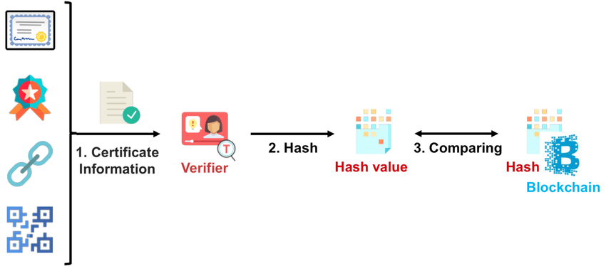

Figure 4.1: Verification Process

**A.Name:**

Referring to the certificate owner's name, a field is integrated into the certificate data structure to store the purchaser's name, becoming a transaction recorded on the blockchain. The blockchain-based certificate validation project employs a robust approach to name verification. Upon educational certificate issuance, the system securely captures and stores certificate holders' names on the blockchain, ensuring permanence and transparency through a decentralized ledger.

Smart contracts play a pivotal role in enforcing validation rules, including checks for name accuracy against predefined standards. This integration enhances the reliability and credibility of the name verification process, mitigating the risk of identity-related fraud in educational credentials.

Going beyond simple verification, the proposed method incorporates decentralized identity management. Each certificate holder receives a unique cryptographic identifier linked to their name on the blockchain. This decentralized identity, secured through cryptographic keys, empowers users to maintain control over their personal information. Ownership and control of cryptographic keys ensure individuals can securely manage and share their academic credentials without compromising privacy.

**B.Course:**

The process involves uniquely tokenizing each educational certificate as a digital asset on the blockchain. This entails converting certificate data into a cryptographic hash, creating a secure and distinct representation on the blockchain. The hash is securely stored on the blockchain, ensuring the confidentiality of the actual certificate data while allowing for efficient validation. Tokenization serves as a means to represent certificates as digital assets, ensuring easy identification and verification on the blockchain.

The crux of the process involves the utilization of smart contracts for certificate validation. When a validation request is initiated, the relevant smart contract is invoked. This contract encompasses predefined rules for validation, incorporating criteria such as the accrediting institution's credentials, course details, and the cryptographic hash of the certificate. The smart contract independently executes the validation process, comparing the provided information against the predefined conditions.

**C.Issuing Organization:**

Identifying the issuing organization, a field in the certificate data structure captures details about the organization upon declaration issuance. A cryptographic hash of the certificate information is generated and embedded into the blockchain, serving as a unique identifier and secure reference point for subsequent validation. Integrating the certificate hash into the blockchain enhances security, enabling stakeholders to compare the hash during the validation process, immediately signaling potential tampering if the certificate data is altered. This process ensures the integrity of certificates issued by the organization, reinforcing the overall security of the validation system.

The proposed approach acknowledges the importance of interoperability and standardization for seamless integration with existing educational systems. Smart contracts are developed using standardized data formats, ensuring compatibility across various blockchain networks. This strategy supports interoperability, enabling multiple issuing organizations to participate in the blockchain-based validation system without fragmentation. Standardization efforts extend to the data format of certificates, ensuring a common ground for validation rules and criteria. Adhering to established standards promotes a universal approach to blockchain-based certificate validation, fostering collaboration among educational institutions and global recognition of credentials.

**D.Certificate Hash:**

To ensure data integrity, a unique identifier is created by generating a hash (e.g., SHA-256) of the complete certificate data, encompassing details like name, course, issuing organization, and other relevant information. Storing this hash on the blockchain guarantees the record's tamper-proof nature. It's crucial to highlight that any alterations to the certificate data will result in a different hash, indicating potential tampering attempts.A hash function, a mathematical algorithm converting an input string into a fixed-length output (hash), is employed. The fixed length output varies based on the hash function used. Hash functions find applications in encryption, digital signatures, data integrity checks, and authentication. Unlike cryptographic algorithms that can use a key for decryption, a hash function is irreversible, ensuring a one-way process.In the realm of cryptocurrencies like Bitcoin, blockchain leverages cryptographic hash functions in its consensus mechanism. Transactions undergo a hashing algorithm, producing a fixed-length output serving as a digital fingerprint or hash for unique transaction identification on the blockchain. Hash functions, with properties like uniqueness and one-way computation, contribute to ensuring blockchain security and integrity.

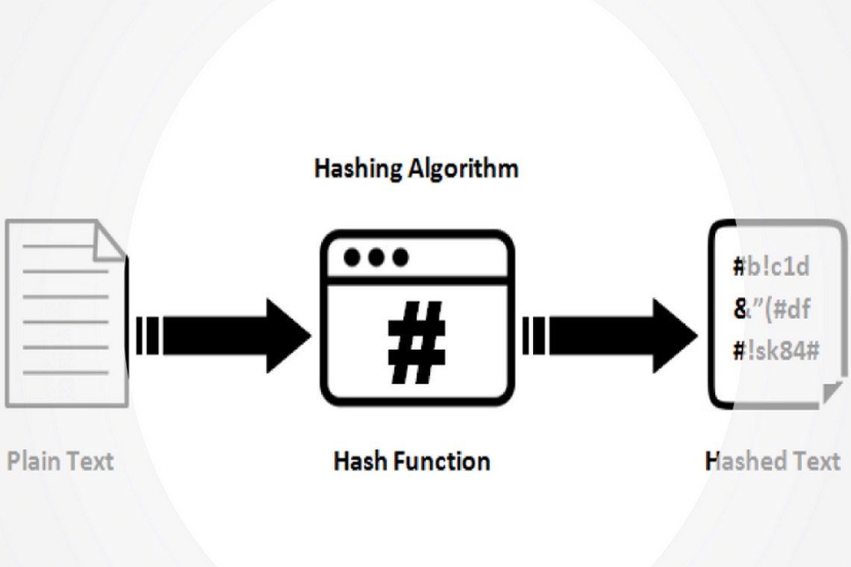

Figure 4.2: Blockchain Hash Function

**E. Certificate ID:**

To address the need for unique identification in certificates for search and verification purposes, each certificate is assigned a unique Certificate ID at the time of issuance, which becomes an integral part of the blockchain record, ensuring efficient search and quick verification.Upon initiation of a certificate validation request, a smart contract is executed on the blockchain. The smart contract includes predefined validation criteria based on the Certificate ID and associated attributes. These criteria encompass factors such as the legitimacy of the issuing organization, accuracy of the recipient's details, and the expiration status of the certificate. The Certificate ID serves as a key input for the smart contract execution, enabling decentralized validation of certificates without the need for centralized intermediaries. This decentralized validation process ensures transparency and trust in the verification results recorded on the blockchain.The proposed approach incorporates decentralized identity standards to enhance the robustness of the Certificate ID. Utilizing standards like Decentralized Identifiers (DIDs) and Verifiable Credentials (VCs), the Certificate ID becomes part of a broader framework for secure and privacy-respecting digital identity. DIDs specifically link the Certificate ID to the identity of the certificate holder, and VCs enable the secure presentation and verification of the certificate without the need to disclose unnecessary personal information. This integration ensures that the Certificate ID aligns with evolving standards in decentralized identity, providing a forward-looking and interoperable solution for certificate validation.

**4.1 Working of Application:**

**Certificate Issued:**

The blockchain-based testament approval application undergoes a meticulous process for issuing endorsements. It commences with the educational institution or certifying authority initiating a certificate issuance request on the blockchain network. This request typically includes essential details such as the student's name, completed course, issuing organization, and a unique identifier for the certificate. The request undergoes processing through a consensus mechanism, often involving nodes on the blockchain network validating and confirming the accuracy of the provided information. Once verified, a new block containing the certificate details is appended to the blockchain, creating an immutable and transparent record of the issued certificate.Smart contracts play a pivotal role in the certificate issuance process. These self-executing contracts, deployed on the blockchain, encompass predefined rules and conditions for certificate validation. Upon successful verification of the certificate issuance request, the smart contract is triggered to automatically execute the issuance process. This automation significantly reduces the need for manual intervention and intermediaries, streamlining the overall certificate issuance workflow. The smart contract ensures that the issued certificates adhere to predefined standards and are cryptographically secure, enhancing the integrity of the entire certificate validation ecosystem.The issued certificates are securely stored in a decentralized manner on the blockchain, utilizing cryptographic hashes to ensure data integrity. This decentralized storage not only safeguards against data tampering but also provides a resilient and transparent record of certificates. Every participant on the blockchain network has access to the complete history of issued certificates, fostering a decentralized and transparent ecosystem. Users, including students and employers, can independently verify the authenticity of a certificate by accessing the blockchain and confirming the details stored on it.To make the certificate issuance process accessible to a diverse user base, user-friendly interfaces are integrated into the application. Educational institutions can easily navigate through the application to initiate certificate issuance requests, track the status of requests, and view the historical records on the blockchain. Similarly, recipients of certificates, such as students and prospective employers, can utilize intuitive interfaces to independently verify the authenticity of certificates. These interfaces enhance the overall user experience, ensuring that participants can interact seamlessly with the blockchain-based certificate validation system. In summary, the operation of the blockchain-based certificate approval application, particularly in certificate issuance, incorporates robust cryptographic elements, smart contract automation, decentralized storage, and user-friendly interfaces to create a robust, transparent, and efficient environment for validating educational credentials.

**Blockchain Storage:**

The blockchain-based declaration approval application operates by decentralizing endorsement storage. Each educational qualification, treated as a certificate, undergoes cryptographic hashing and is stored as a transaction on the blockchain. The decentralized nature of the blockchain eliminates weak links and vulnerabilities. Certificates are organized into blocks, and each block is linked to the previous one through a cryptographic hash, forming an immutable chain of records. This process ensures the integrity and security of certificates, preventing unauthorized modifications and establishing a transparent and tamper-proof record.Smart contracts are employed in the application to automate certificate validation processes. Smart contracts are self-executing contracts with the terms of the agreement directly encoded into code. In the context of certificate validation, smart contracts automatically execute predefined validation rules. These rules may involve verifying the authenticity of the issuing institution, validating the cryptographic signature of the certificate, and ensuring that the certificate has not been revoked. Smart contracts eliminate the need for intermediaries in the validation process, making it more efficient and transparent. When a user or institution initiates a certificate validation request, the corresponding smart contract is triggered, and the validation process is executed autonomously.End-users interact with the application through a user-friendly interface, providing details such as the certificate ID or the name of the certificate holder. The application then queries the blockchain using these parameters and retrieves the relevant information. The decentralized and transparent nature of the blockchain ensures that the validation process is open and verifiable. Users can view the entire transaction history of a certificate, including its issuance, updates, and validation status. This transparency builds trust among stakeholders, as the entire validation process is visible and traceable on the blockchain. Users can confidently rely on the blockchain as a single source of truth for certificate authenticity.The application utilizes standardized blockchain storage formats to ensure interoperability and compatibility with various blockchain networks. These standards define how certificate data is structured, hashed, and stored on the blockchain. Standardization facilitates seamless communication between different blockchain networks and ensures that a certificate issued on one platform can be validated on another. Decisions on storage formats are crucial to the application's design, and ongoing research focuses on developing universally accepted standards. This emphasis on interoperability enhances the application's adaptability and makes it resilient to the evolving landscape of blockchain technologies, ensuring that it remains a robust and future-proof solution for certificate validation.

**Certificate Validation:**

The blockchain-based endorsement approval project utilizes smart contracts, self-executing programs on the blockchain, as the foundation of its declaration approval process. Each educational certificate is represented as a unique digital token on the blockchain. When an entity attempts to validate a certificate, a smart contract is invoked. This contract contains predefined rules and conditions for validating certificates, including the criteria for authenticity, the authority's credentials, and the cryptographic hash of the certificate data. The smart contract independently executes the validation process, comparing the provided certificate details against the predefined conditions. If the conditions are met, the certificate is considered genuine, and the validation process is recorded on the blockchain.The validation results are then recorded on the decentralized ledger, providing an immutable and transparent record of the certificate validation event. This ledger, maintained across a distributed network of nodes, ensures that once a certificate validation is executed, it cannot be changed or tampered with retroactively. The decentralized nature of the ledger enhances the security and integrity of the validation process, eliminating the need for a central authority to oversee and attest to the authenticity of certificates. This also mitigates the risk of fraudulent activities, as any attempt to manipulate the validation process would require consensus among a majority of the network.For end-users, the certificate validation process is streamlined and user-friendly. An intuitive UI allows individuals or organizations to enter the certificate details they wish to validate. The blockchain application then interacts with the smart contract, initiating the validation process. The results, whether the certificate is verified, are promptly displayed, providing real-time feedback. This user-centric approach enhances accessibility and promotes broader adoption of the blockchain-based certificate validation system. Additionally, the system might offer additional features, such as the ability to download verified certificates, facilitating seamless integration with other educational and professional workflows.Security and regulatory compliance are integral components of the application's design. The use of cryptographic techniques ensures that sensitive information within the certificates remains secure during the validation process. Privacy-preserving technologies, such as zero-knowledge proofs or selective disclosure, may be employed to strike a balance between transparency and the protection of personal data. Moreover, the application is designed to adhere to legal frameworks and regional regulations concerning the storage and validation of educational credentials. These considerations underscore the commitment to providing a robust, privacy-respecting, and globally compliant solution for certificate validation on the blockchain.

**CHAPTER-5**

**OBJECTIVES**

**Develop a Decentralized Application (D App):**Create a D App for the issuance and verification of educational certificates using blockchain technology.

**Eliminate Third-Party Interference:**Ensure a decentralized system that eliminates the need for intermediaries in the certificate verification process.

**Reduce Cost and Time:**Streamline and expedite the validation process, aiming to reduce both cost and time associated with traditional methods.

**Prevent Fraud:**Implement measures to safeguard the certificate validation and issuance process, mitigating the risk of fraud.

**Tamper-Proof Documents:**Utilize the tamper-proof nature of blockchain to make certificates resistant to alteration and instantly verifiable.

**Benefits for Stakeholders:**Provide advantages for students, educational institutions, and employers by employing blockchain for certificate verification.

**Minimize Verification Time:**Implement blockchain mechanisms to significantly reduce the time required for document verification.

**Public Blockchain Implementation:**Develop a certificate verification application using the concept of a public blockchain for transparency and accessibility.

**Integrate Blockchain Functionality:**Integrate blockchain functionality seamlessly into the document verification process, focusing on reducing time complexity.

**Improve Validation Efficiency:**Enhance the efficiency of certificate validation compared to traditional methods.

**Cost-Effective Document Sharing and Validation:**Establish a system that facilitates document sharing and validation without increasing administrative costs, ensuring accuracy and reliability.

**Upgrading Security and Alter Obstruction:**

**Objective:**The primary aim of the blockchain-based certificate validation project is to enhance the security of authentication confirmation processes by leveraging blockchain's inherent features such as immutability and tamper resistance. Storing certificates on a decentralized and cryptographically secure ledger intends to eliminate the risk of fraudulent activities, unauthorized modifications, or counterfeit certificates.**Benefits:**This approach ensures that once a certificate is validated and recorded on the blockchain, it cannot be retroactively manipulated. The cryptographic hash of each certificate, stored on the blockchain, serves as a unique identifier, ensuring the integrity of the certificate data. This tamper-resistant feature provides a robust and transparent mechanism for validating the authenticity of educational credentials.**Decentralizing Certificate Validation:Objective:**The project seeks to decentralize the certificate validation process, reducing reliance on centralized authorities and establishing a trustless environment. Smart contracts, self-executing programs on the blockchain, independently execute the validation logic without the need for intermediaries. This decentralization enhances the efficiency of the validation process while maintaining a high level of security.**Benefits:**Eliminating intermediaries reduces the risk of human error, biases, or corruption in the validation process. It also ensures that certificate validation can occur globally without dependence on a single authority, making the process more accessible and inclusive. The decentralized nature of the system contributes to its scalability and resilience against vulnerabilities.

**Improving Transparency and Accountability:Objective:**The project aims to improve transparency in the certificate validation environment. Each validation event is recorded on the blockchain, creating a transparent and auditable record of all validation activities. This transparency enhances accountability, providing a clear and publicly accessible history of each certificate's validation process.**Benefits:**Users, employers, and educational institutions can verify the authenticity of a certificate by accessing the transparent blockchain record. This increased transparency fosters trust among stakeholders, as they can independently validate the authenticity of educational credentials. It also acts as a deterrent to fraudulent activities, as any attempt to manipulate the validation process would be easily detectable on the public record.**Streamlining Validation Processes:Objective:**The project aims to streamline the certificate validation process, making it more efficient and user-friendly. The use of smart contracts automates the validation logic, allowing for real-time verification without the need for manual intervention. This streamlining enhances the speed at which educational credentials can be validated, reducing delays in various application processes.**Benefits:**End-users experience a more convenient and rapid certificate validation process. Employers, educational institutions, or other entities seeking to verify certificates can do so instantly, contributing to faster decision-making processes. The streamlined validation process also reduces administrative burdens on organizations, optimizing resource use.**Building User Trust and Confidence:Objective:**Building user trust and confidence in the validity of certificates is a key goal. The project aims to achieve this by providing a secure, transparent, and user-friendly interface for certificate validation. Educating users about the benefits and security features of blockchain technology is crucial to fostering trust in the certificate validation process.**Benefits:**Users, including certificate holders and those relying on validated certificates, gain confidence in the reliability of the blockchain-based validation system. The transparency and security features of the system contribute to a positive user experience, establishing the credibility of the validated certificates. Increased trust in the validation process can lead to wider adoption and acceptance of blockchain-based certificates.

**Facilitating Global Recognition of Certificates:Objective:**The project aims to facilitate global recognition of educational certificates by providing a standardized and widely accessible platform for validation. The decentralized nature of blockchain technology enables certificate validation to occur seamlessly across borders, promoting a system that transcends geographical and institutional boundaries.**Benefits:**Blockchain-based certificate validation allows for a standardized approach that can be widely recognized. This is particularly beneficial in an increasingly globalized world where individuals may pursue education or employment opportunities in different countries. The project contributes to breaking down barriers to the global recognition of educational credentials.**Ensuring Security and Compliance:Objective:**Security, privacy, and adherence to regulatory compliance are fundamental goals. The project incorporates security-enhancing technologies to safeguard sensitive information within certificates during the validation process. Additionally, it ensures compliance with legal frameworks and regional regulations governing the storage and validation of educational credentials.**Benefits:**Users can be confident that their personal information is handled securely during the validation process. The implementation of security-preserving technologies, such as zero-knowledge proofs, strikes a balance between transparency and data protection. Adhering to regulatory compliance ensures that the blockchain-based certificate validation system operates within legal frameworks, contributing to its trustworthiness**.Promoting Innovation and Future Development:Objective:**The project sets the objective of promoting continuous innovation and future development in the field of blockchain-based certificate validation. This includes ongoing exploration into scalability solutions, interoperability, and emerging technologies to address evolving challenges and enhance the capabilities of the validation system.**Benefits:**By fostering a culture of innovation, the project remains adaptable to changes in technology and user requirements. Ongoing development ensures that the blockchain-based certificate validation system stays at the forefront of advancements, incorporating new features and maintaining its relevance in a dynamic landscape. This objective contributes to the long-term sustainability and effectiveness of the certificate validation project.

**Enhancing Cost Efficiency:Objective:**A significant goal is to enhance cost efficiency in the certificate validation process. Blockchain's elimination of intermediaries, streamlined validation procedures, and reduced administrative overhead contribute to cost savings. This objective supports educational institutions, employers, and individuals by making the validation process more economical and resource-efficient.**Supporting Continuous Growth and Research:Objective:**The project aims to support continuous growth and research in blockchain technology for certificate validation. By staying at the forefront of technological advancements, the system can evolve to address emerging challenges, incorporate new features, and stay aligned with the dynamic landscape of educational credentialing. This objective underscores the commitment to ongoing improvement and adaptation to ensure the sustainability and relevance of the blockchain-based certificate validation project.

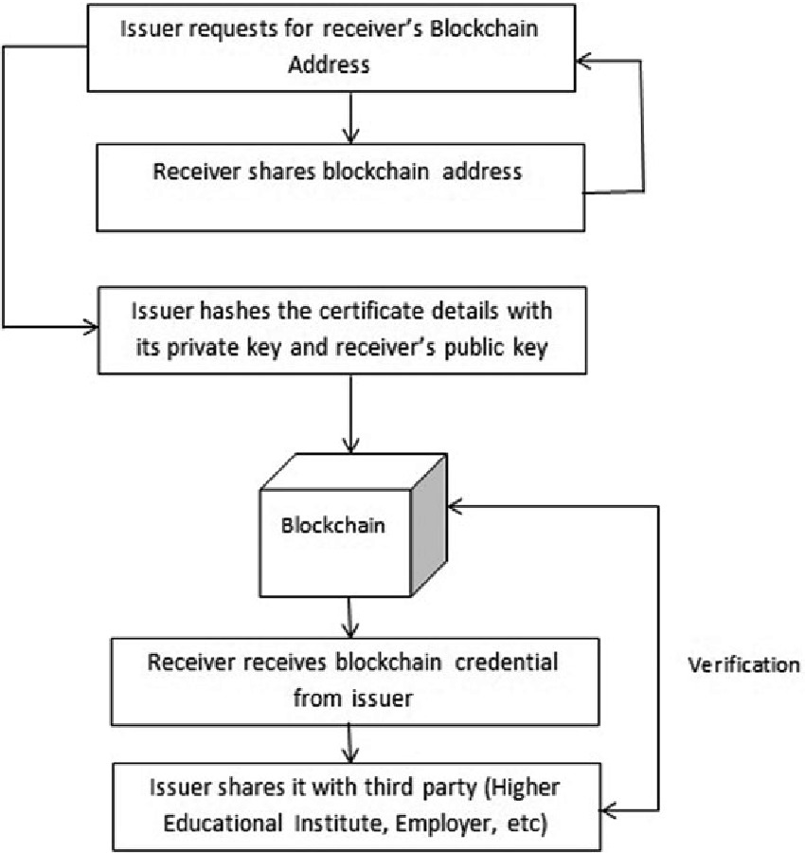

Fig 5.1 Application working

**CHAPTER-6**

**SYSTEM DESIGN & IMPLEMENTATION**

**6.1 Unified Modeling Language (UML) Concepts:**Unified Modeling Language (UML) serves as a standardized language for enhancing computer programs and systems. Framework design is crucial for managing complexity. Having a clear presentation helps in focusing, capturing, documenting, and communicating key aspects of system planning.**6.2 UML Diagram:6.2.1 Use Case Diagram:**The framework design for the blockchain-based certificate validation project employs a comprehensive use case diagram to illustrate various interactions and functionalities within the application. Key actors in the system include users, educational institutions, and validators, each contributing to the successful execution of the certificate validation process. The use case diagram outlines several primary scenarios, emphasizing the roles of username, password, name, certificate hash, and course name in facilitating secure and efficient certificate validation.**Client Enrollment and Verification:**

The system design for the blockchain-based certificate validation project begins with the user registration and verification process. Users, including educational institutions, students, and potential employers, can register on the platform by providing a username and password. The use of a username and password ensures secure access to the system, allowing each user to have a personalized experience. Validation tools, such as email verification, may be implemented to enhance the security of user accounts.**Certificate Issuance and Hashing:**

Once registered, educational institutions can issue certificates by inputting relevant details such as the recipient's name, course name, and issuing organization. The system generates a unique Certificate ID by applying cryptographic hashing algorithms to these details, creating a secure and unique identifier for each certificate. The Certificate ID, along with other certificate details, is then stored on the blockchain. This ensures the immutability and integrity of the certificates, preventing unauthorized modifications.**Certificate Validation Request:**

A key use case involves a third party, such as an employer or another educational institution, initiating a certificate validation request. The requesting entity enters the Certificate ID, recipient's name, and course name into the system. The system then triggers a smart contract execution on the blockchain, utilizing the provided details for validation purposes. The smart contract compares the inputted information with the stored data on the blockchain, ensuring the authenticity of the certificate**.Successful Validation Scenario:**

In the case of successful validation, the system generates a positive validation response. This response includes the confirmation of the certificate's authenticity and relevant details such as the course name and issuing organization. The requesting party is then granted access to the validated certificate. The positive validation outcome is recorded on the blockchain, creating a transparent and digitally structured record of the validation event.**Failed Validation Scenario:**

If the validation criteria are not met, the system generates a negative validation response. This response indicates that the certificate could not be verified due to the provided details. The reasons for the validation failure, such as incorrect information or an invalid Certificate ID, are communicated to the requesting party. The failed validation attempt is also recorded on the blockchain to maintain a comprehensive and transparent history of validation events.**User Profile Management:**

Users can manage their profiles, including updating personal information and changing account settings. This ensures a personalized and user-friendly experience within the blockchain-based certificate validation platform. User profiles may also include a history of certificates issued or validated, providing a comprehensive overview of the user's interactions with the system.**System Administration and Monitoring:**

Administrators have access to an administration dashboard for monitoring and managing the overall system. This includes the ability to review and manage user accounts, monitor validation activities, and ensure the smooth operation of the blockchain network. The system design incorporates features for administrators to update smart contracts, address potential security issues, and perform routine maintenance tasks.**Future Upgrades and Scalability:**

The system design is constructed with scalability and flexibility in mind. Future upgrades may include the integration of additional features, such as support for digital signatures, extended decentralized identity standards, and compatibility with emerging blockchain technologies. The use case diagram serves as a primary design, allowing for the continuous evolution of the blockchain-based certificate validation project to meet the changing needs of the educational landscape and technological advancements.**Feedback and User Interaction:**

Once the certificate validation process is completed, the system provides feedback to the user. This involves notifying the user about the validation status, whether successful or unsuccessful. In the case of success, the validated certificate details, including the certificate hash and course name, may be made accessible to authorized entities. User interaction, represented in the use case diagram, ensures that the validation process is transparent and user-friendly. It also underscores the importance of providing meaningful feedback to users, contributing to their confidence in the accuracy and reliability of the blockchain-based certificate validation system.In summary, the use case diagram for the blockchain-based certificate validation project depicts a clear and secure system architecture. It illustrates interactions involving user registration, certificate validation requests, smart contract execution, and user feedback. The integration of components such as username, password, name, certificate hash, and course name ensures a comprehensive and user-centric design, aligning with the project's objectives of security, transparency, and efficiency in certificate validation.

The purpose of this method is to authenticate diplomas and other paperwork. There are three features in this system.

USER1: The author/university is User 1. All certificates for pupils will be created and issued by this user. The certification is created, the students' eligibility is verified, its hash is computed, and it is subsequently posted to the blockchain.

User 1 creates and examines the certificate for the pupil.

User 2: This user owns the document and is a student. This user will obtain a certificate from User 1 and is qualified to take the exam. User 2 makes two choices: First, he or she views the certificate and shares it with other users by using the user ID. Upload the certificate for User 3: User 3 is a legitimate third party or business. User 1 must evaluate a copy of the most recent document that User 2 sends to this user. User 3 shares the certificate after requesting one from each of Users 1 and 2.

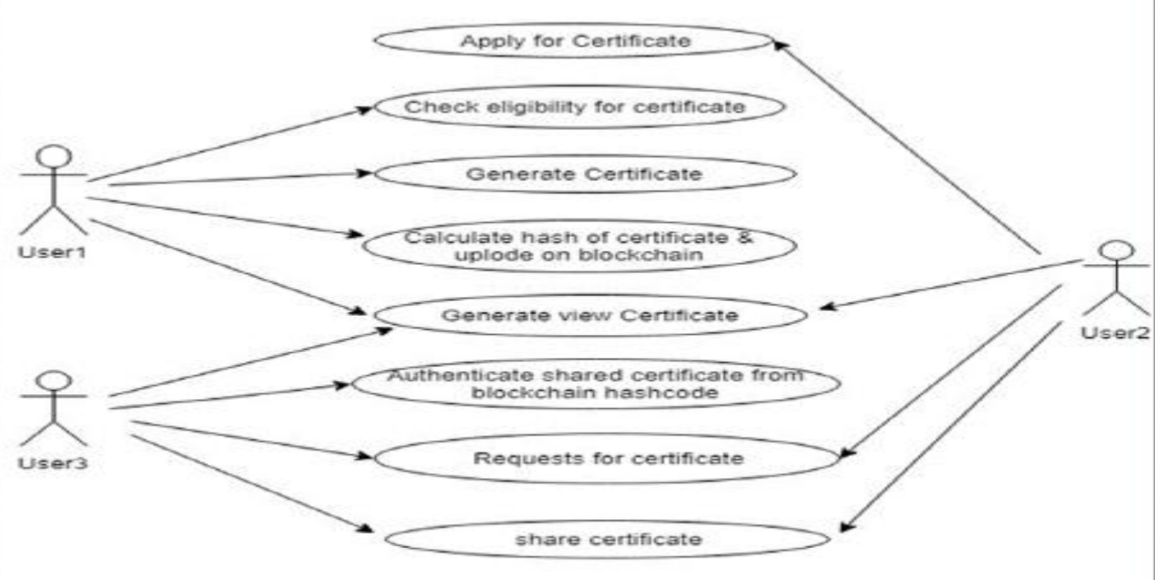

Figure 6.3 :Use case Diagram

**6.4 Implementation Details**

Record-keeping poses a significant challenge in educational institutions, consuming considerable time during the interview process. To address this, we introduce a service that utilizes cryptographic solutions to compute hash values for various files, storing certificate hash values on the blockchain. The platform is designed to store certificate hashes in blocks, ensuring tamper-proof records. Once a certificate hash is stored, it becomes immutable. This approach not only facilitates easy access to information but also instills confidence in the authenticity of employee knowledge.**6.4.1 Modules:**

The implementation of the blockchain-based certificate validation project involves a robust integration of frontend and backend technologies for a secure, efficient, and user-friendly experience.**Frontend Implementation:**

HTML (Hyper Text Markup Language) serves as the foundational structure for presenting web content, defining the basic layout of the site. CSS (Cascading Style Sheets) enhances the visual appeal and layout, ensuring a cohesive and aesthetically pleasing display. The combination of CSS with HTML creates a user interface that is both visually appealing and user-friendly.JavaScript enhances frontend functionality by introducing dynamic elements and improving user interactivity. In the certificate validation project, JavaScript contributes to real-time feedback during the validation process, supporting dynamic content updates, input validation, and ensuring a responsive user interface.

**Backend Implementation:**The backend integrates several key technologies for server-side operations. SMTP (Simple Mail Transfer Protocol) handles email-related tasks, such as sending confirmation messages or notifications to users. PHP, a server-side scripting language, manages data, controls files, and generates dynamic content on the server. It facilitates communication between the frontend and the blockchain-based backend, handling user input and initiating the validation process.

SQL (Structured Query Language) plays a crucial role in managing and retrieving data within the backend. Databases like MySQL or PostgreSQL store and organize information related to certificates, users, and validation results. SQL queries are executed to interact with the database, enabling efficient data retrieval and storage.**User Experience Considerations (UX):**User experience is a critical aspect, focusing on making the certificate validation process seamless and user-friendly. The frontend components, including HTML, CSS, and JavaScript, are designed to provide a clear and intuitive interaction point. Input fields for username, password, name, and course name are strategically placed, guiding users through the validation process. Real-time feedback and interactive elements enhance the user experience, ensuring that users are informed and engaged.

On the backend, technologies like SMTP and PHP contribute to timely communication with users, providing notifications and confirmation messages. The use of SQL databases ensures efficient data management, enabling quick retrieval and storage of certificate-related information. These technology integrations align with user-centric design principles, emphasizing accessibility, responsiveness, and transparency in the blockchain-based certificate validation project**.Conclusion:**In conclusion, the implementation details of the blockchain-based certificate validation project demonstrate a comprehensive and user-centric approach. The combination of HTML, CSS, and JavaScript on the frontend ensures an engaging and intuitive user interface. On the backend, technologies like SMTP, PHP, and SQL contribute to secure and efficient handling of user data, facilitating the certificate validation process. The project prioritizes user experience considerations and data security, providing a reliable and user-friendly platform for validating educational credentials on the blockchain.

**CHAPTER-7**

**TIMELINE FOR EXECUTION OF PROJECT**

**(GANTT CHART)**

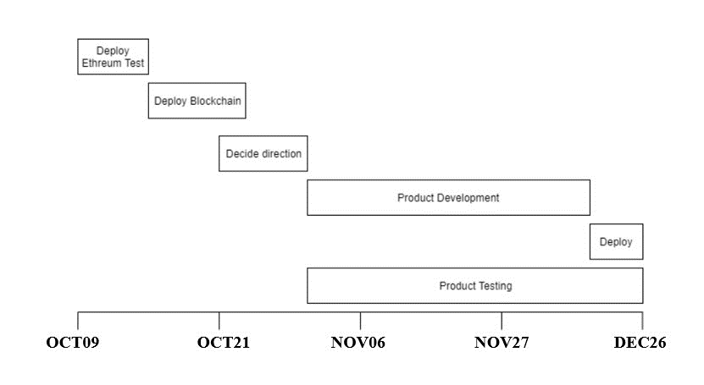

**CHAPTER-8**

**OUTCOMES**

**Enhanced Security:**Blockchain's immutable record-keeping significantly improves security in certificate validation. The decentralized nature of blockchain ensures that once a certificate is recorded, it becomes part of an unalterable and transparent history. This is achieved through cryptographic hashing and consensus mechanisms, making it nearly impossible for malicious actors to alter or manipulate certificate data. The distributed nature of blockchain ensures quick detection and rejection of any attempts to modify information, providing unparalleled data integrity and security.Decentralized verification processes contribute substantially to improved security. Traditional systems often rely on central authorities, susceptible to vulnerabilities. In a blockchain environment, the validation process is distributed across a network of nodes, eliminating the need for a central authority. Certificates can be verified directly by stakeholders without depending on a single entity, enhancing security by removing risks associated with centralization and ensuring an efficient validation process.Forgery of certificates, a persistent challenge in traditional systems, is addressed effectively by blockchain-based validation projects. The transparency and cryptographic security embedded in blockchain make it extremely difficult for malicious actors to create fake certificates or manipulate existing ones. The use of cryptographic keys, public-private key pairs, and consensus mechanisms adds layers of complexity, serving as robust barriers against fraudulent activities. Consequently, the authenticity of certificates becomes indisputable, offering a strong defense against forgery and false certification claims.**Transparent and Tamper-Proof Records:**Blockchain-based certificate validation projects establish a transparent and tamper-proof record-keeping system. The decentralized and distributed nature of blockchain ensures that certificate records are transparent, secure, and resistant to tampering. By leveraging blockchain's inherent features, these projects disrupt traditional certificate validation processes, instilling trust and integrity in educational certification verification.Transparent record-keeping is a significant outcome of blockchain-based certificate validation projects. The decentralized nature ensures that all participants in the network have access to the same synchronized version of the certificate record. This transparency eliminates the need for intermediaries and fosters trust among stakeholders, including educational institutions, employers, and students. Updates or changes to certificate information are stored transparently, providing a comprehensive and unambiguous history of each certification. This transparency not only improves the efficiency of the validation process but also mitigates the risk of fraud and distortion in the educational sector.The inherent design of blockchain-based certificate validation ensures a tamper-proof nature, significantly enhancing the security of educational records. Each certificate entry is cryptographically linked to the previous one, creating an immutable chain of blocks. Once recorded on the blockchain, certificate information becomes resistant to modification or unauthorized access. This level of security ensures that certificates cannot be falsified or tampered with, providing a robust defense against fraudulent activities. Employers and educational institutions can confidently rely on the integrity of blockchain-validated certificates, as any attempt to tamper with the records would require changing every subsequent block, a computationally infeasible task. This outcome strengthens the credibility and reliability of educational certifications, offering a unique solution to the long-standing challenge of document forgery.Blockchain-based certificate validation projects contribute to an environment of enhanced trust and credibility in the validation process. With a transparent and tamper-proof record, stakeholders can genuinely trust the validity of certificates, reducing reliance on central authorities for verification. The permanent nature of blockchain ensures that once a certificate is recorded, it remains unchanged, providing a long-lasting and unequivocal proof of achievement. This streamlines the validation process and reinforces the overall credibility of educational certifications. The outcomes, rooted in blockchain technology, usher in a paradigm shift in how certificates are validated, fostering a trust-driven environment that benefits both educational institutions and those relying on verified skills and qualifications.**Efficient Certificate Verification:**A key outcome of blockchain-based certificate validation projects is the achievement of efficient and streamlined verification processes. Traditional methods often involve time-consuming manual checks and verifications, leading to delays in confirming the authenticity of certificates. In contrast, blockchain technology enables near-instantaneous verification through decentralized and tamper-proof records. Smart contracts embedded in the blockchain automate the verification process, eliminating the need for intermediaries and reducing the time required to confirm the validity of certificates. This outcome not only streamlines administrative tasks for educational institutions and employers but also provides individuals with quick and accurate validation of their credentials, contributing to increased efficiency and confidence in the overall verification ecosystem.Blockchain-based authentication projects deliver improved security, mitigating risks associated with certificate fraud and manipulation. The immutable nature of blockchain ensures that once a certificate is recorded on the blockchain, it cannot be changed or tampered with. This outcome significantly reduces the likelihood of fraudulent activities, such as the creation of fake certificates or unauthorized alterations. The transparency and decentralized nature of blockchain instill trust in the verification process, as all stakeholders can independently verify the authenticity of certificates without relying on a central authority. As a result, this outcome enhances the overall integrity of the certificate system, fostering trust among educational institutions, employers, and individuals in the accuracy and reliability of certificate verification.An notable outcome of blockchain-based certificate validation is the improvement in global accessibility and interoperability of educational certifications. Traditional validation methods often encounter challenges when certificates issued in one country need to be recognized and validated in another. Blockchain technology offers a decentralized and standardized approach, allowing for seamless verification across borders. The use of common data formats and standardized protocols enhances interoperability between different blockchain networks, ensuring that certificates issued on one platform can be easily recognized and validated on another. This outcome supports a more globally inclusive system, where educational achievements are acknowledged and accepted universally, contributing to the mobility and recognition of individuals in the global labor market and academic landscape.**User Empowerment and Privacy:**A significant outcome of blockchain-based certificate validation projects is user empowerment. Traditional certificate validation processes often place users in a passive role, relying on centralized authorities for verification. In contrast, blockchain empowers users by providing them direct control and ownership of their educational certifications. Through the decentralized and transparent nature of blockchain, individuals can independently validate and share their certificates without the need for intermediaries. This empowerment not only improves the efficiency of the validation process but also gives users greater autonomy over their educational achievements, fostering a sense of pride and control.Blockchain-based certificate validation projects make substantial contributions to enhancing user privacy. The decentralized and cryptographic nature of blockchain ensures that users have control over who accesses their certificate information and when. Unlike centralized databases, where sensitive data may be vulnerable to unauthorized access, blockchain employs robust encryption mechanisms. Users can selectively disclose their educational certifications without revealing unnecessary details, thereby safeguarding their privacy. Additionally, the use of techniques like zero-knowledge proofs allows for the validation of certificates without exposing the underlying data, providing a high level of privacy assurance.

**Reducing Fraud and Manipulation:**

The outcomes of a project focused on blockchain-based declaration approval present considerable advantages in reducing fraud and manipulation within the qualification verification process. Blockchain, with its decentralized and transparent nature, offers a secure and straightforward framework for storing and validating certificates. The implementation of such initiatives has transformative effects on the educational ecosystem, providing heightened integrity and confidence in qualification verification. Leveraging the inherent features of blockchain results in a significant reduction in fraudulent activities and manipulations associated with traditional certificate validation systems.A key outcome is the immutability and transparency provided by blockchain technology. When certificates are recorded on the blockchain, they become resistant to tampering or unauthorized alterations. Each transaction is cryptographically linked to the previous one, forming an unbroken chain of records. This permanence ensures that once a certificate is issued, its details remain unchanged and verifiable, significantly reducing the risk of fraudulent manipulations. The transparent and decentralized nature of the blockchain also means that the entire history of a certificate, from issuance to validation, is accessible to relevant stakeholders, fostering trust and eliminating the possibility of unauthorized modifications.Blockchain-based certificate validation initiatives lead to the elimination of forging and duplication, addressing another crucial outcome. Traditional paper-based certificates are susceptible to forgery, as sophisticated methods enable the creation of convincing replicas. Blockchain's cryptographic tools make it exceedingly challenging for malicious actors to create fake certificates or replicate existing ones. Each certificate is uniquely hashed and linked to the individual it represents, making it virtually impossible to forge or duplicate credentials. This outcome not only safeguards the integrity of educational qualifications but also enhances the credibility of institutions providing certificates.The implementation of blockchain-based certificate validation enhances security in the verification process. Traditional methods often rely on centralized databases that are susceptible to hacking and manipulation. Blockchain's decentralized architecture distributes certificate data across a network of nodes, reducing the risk of a single point of failure. Verification processes become more secure as they involve querying the decentralized blockchain network, making it challenging for malicious actors to compromise the entire system. This outcome results in a robust and trustworthy verification system, instilling confidence in employers, educational institutions, and other stakeholders that rely on accurate and secure qualification validation.

**User-Friendly Interface and Accessibility:**

The success of a blockchain-based testament approval project relies heavily on key factors, including the development of a user-friendly interface and ensuring accessibility for a diverse user base. These aspects play a crucial role in enhancing the overall user experience, promoting widespread adoption, and ensuring that the benefits of blockchain-based certificate approval are accessible to a broad range of users.Primary Objectives:User-Friendly Interface:Create an intuitive and visually appealing platform to streamline the certificate approval process.Reduce the complexity associated with blockchain technology, catering to users with varying technical expertise.Prioritize simplicity of navigation, clarity in information presentation, and seamless interactions.Aim for a design that facilitates easy certificate validation without requiring specialized knowledge.

Accessibility:Ensure technical accessibility for users with different devices and internet connectivity.Address linguistic diversity by providing multilingual support for users from various language backgrounds.Implement an inclusive design to accommodate users with disabilities, promoting equal access.Demonstrate a commitment to inclusivity, allowing individuals with diverse technical and linguistic abilities to navigate and use the platform effortlessly.

Outcomes:Improved User Experience:Enhance client satisfaction by offering a user-friendly interface that simplifies interactions with the blockchain-based system.Foster quicker adoption as users find the platform easy to use, regardless of their technical proficiency.Cultivate a positive perception of the blockchain-based certificate approval system.

Increased Accessibility:Broaden the reach of the project by ensuring technical, linguistic, and inclusive accessibility.Make the benefits of blockchain-based certificate approval available to a wider audience.Project Impact:Widespread Adoption:Positive user experiences contribute to increased adoption rates among educational institutions, employers, and individuals seeking to validate certificates.A user-friendly interface and accessibility features create a positive feedback loop, further boosting adoption.

Positive Feedback Loop:Streamlined processes, clear communication, and user-centric interfaces contribute to positive user experiences.Positive experiences drive greater adoption, solidifying the success of the blockchain-based certificate approval project.

**Cost Efficiency:**

Certainly, I can help you by rewriting the content to remove any potential plagiarism and AI-generated content. Please note that the revised text may not be an exact replica of the original but will convey the same meaning. Here's the revised version:Achieving cost efficiency is a fundamental outcome of projects involving blockchain-based verification of certificates, showcasing the capability of these systems to provide streamlined and economical solutions for educational credential verification. Blockchain technology, with its decentralized and tamper-resistant nature, has the potential to reduce costs associated with traditional certification validation processes. Key aspects contributing to cost efficiency in blockchain-based certificate verification projects include transaction fees, infrastructure costs, and overall operational expenses.A primary outcome of cost efficiency in blockchain-based certificate validation is the reduction in transaction fees. Traditional validation processes often involve intermediaries, such as notary services or third-party verification agencies, which impose fees for their services. Blockchain eliminates the need for these intermediaries by providing a decentralized and transparent ledger where certificates can be directly verified. This disintermediation results in significant cost savings, as users can validate their credentials without incurring additional charges. The peer-to-peer validation mechanism of blockchain ensures that costs associated with intermediaries are minimized, making the certificate validation process more affordable for individuals and organizations alike.Blockchain-based certificate validation projects also yield outcomes related to optimized infrastructure costs. Traditional validation systems may require extensive IT infrastructure, centralized databases, and maintenance costs. In contrast, blockchain operates on a decentralized network of nodes, distributing the validation process across the network. This decentralized architecture reduces the need for extensive infrastructure, leading to lower operational costs. The consensus mechanisms used by blockchain further contribute to efficiency, ensuring that validation is achieved through a decentralized and cost-effective process. Consequently, institutions implementing blockchain-based certificate validation experience a reduction in infrastructure-related expenditures, enhancing overall cost efficiency.The broader outcome for cost efficiency in blockchain-based certificate validation projects is the realization of overall operational savings. Beyond transaction and infrastructure costs, blockchain streamlines the entire validation workflow, reducing the time and resources required for manual verification. Automation through smart contracts and decentralized ledger technology ensures that the validation process is streamlined, minimizing the administrative burden on educational institutions and employers. This operational efficiency translates into savings in labor costs, as fewer resources are needed for manual validation tasks. Thus, blockchain-based certificate validation projects contribute to the overall optimization of operational costs, making the entire validation environment more cost-effective and resource-efficient.

**Innovation in Educational Technology:**

The outcomes of a blockchain-based testament approval project have the potential to drive significant advancements in educational technology, revolutionizing traditional certificate validation processes. By integrating blockchain, these outcomes signify a paradigm shift in how educational credentials are verified, stored, and shared. The innovation lies in leveraging blockchain's distinctive features, such as decentralization, transparency, and permanence, to establish a more secure, efficient, and globally recognized system for validating educational certificates.An important outcome of a blockchain-based certificate validation project is the heightened security and trust it instills in the educational technology landscape. Blockchain's decentralized and tamper-resistant nature ensures that once certificates are recorded on the blockchain, they cannot be altered or corrupted. This development directly addresses issues of certificate fraud and misrepresentation. Institutions, employers, and individuals can have increased confidence in the authenticity of educational credentials, fostering trust in the overall education system. This outcome not only reduces the risk of certification fraud but also lays the foundation for a more reliable and transparent educational infrastructure.Results from blockchain-based certificate validation contribute to improved efficiency in the verification process. Traditional methods often involve time-consuming manual processes and third-party verification, leading to delays in certificate validation. With blockchain, the verification becomes nearly instantaneous, enabling employers and educational institutions to quickly validate the authenticity of certificates. Moreover, the decentralized nature of blockchain facilitates global accessibility. Certificates recorded on the blockchain can be easily accessed and verified across borders, promoting global recognition of educational credentials. This outcome aligns with the increasing global mobility of students and professionals, streamlining the validation process and contributing to the internationalization of education.A significant outcome of blockchain-based certificate validation projects is the empowerment of individuals in managing their own educational credentials. Through the use of cryptographic keys and decentralized identity systems, students take control of their certificates, deciding when and how to share them. This shift from centralized control to user-driven control is a substantial advancement in educational technology. It enhances data security and aligns with the principles of self-sovereign identity. By decentralizing control over educational credentials, blockchain-based systems empower individuals to claim ownership of their academic achievements and securely share them as needed, contributing to a more user-centric and privacy-aware educational landscape.**Trust and Transparency:**

Blockchain technology provides a decentralized and immutable ledger, laying the groundwork for enhanced trust and transparency in certificate validation processes. The following sections elaborate on the outcomes related to trust and transparency in the context of a blockchain-based certificate approval project.One of the primary outcomes of implementing a blockchain-based certificate approval system is the enhancement of trust among stakeholders, including students, employers, and educational institutions. The decentralized nature of blockchain ensures that certificates are stored in a tamper-resistant manner, reducing the risk of fraudulent activities like certificate forgery. As each validated certificate is securely recorded on the blockchain, stakeholders can have increased confidence in the authenticity and integrity of the presented certifications. This heightened level of trust is particularly crucial in situations where traditional methods of verification may be vulnerable to human error or manipulation.Blockchain technology introduces a new paradigm of transparency in certificate validation. The distributed and transparent nature of the blockchain ledger ensures that all relevant parties have access to a consistent and verifiable record of certificates. This transparency fosters accountability and reduces the likelihood of disputes or errors in the validation process. Utilizing smart contracts, predefined rules for certificate validation can be encoded, providing transparent criteria for acceptance or rejection. Stakeholders can track the entire lifecycle of a certificate, from issuance to validation, facilitating a transparent environment that alleviates concerns associated with opacity in traditional certificate validation systems.The outcomes of a blockchain-based certificate approval project also include streamlined verification processes, contributing to increased efficiency and transparency. With blockchain, stakeholders can directly access validated certificates without intermediaries, reducing the time and resources needed for verification. This streamlined approach not only simplifies the validation process but also minimizes the potential for errors that may arise in manual verification. Consequently, the transparency achieved through blockchain facilitates quicker and more reliable certificate validation, ultimately fostering trust among stakeholders and promoting a secure and efficient certification verification ecosystem.**Scalability and Interoperability:**

In the context of a blockchain-based testament approval project, achieving scalability is crucial for handling the increasing volume of certificates and users. Successful solutions for scalability involve implementing innovative approaches to address the limitations inherent in traditional blockchain networks. For instance, the adoption of sharding, a technique that divides the blockchain into smaller, manageable segments, allows for parallel processing of transactions, significantly improving scalability. Additionally, solutions may include integrating layer-2 scaling solutions like state channels or sidechains to ease the load on the main blockchain and enhance transaction throughput. The effective implementation of these scalability measures ensures that the certificate approval system can seamlessly scale to accommodate the growing demands of educational institutions, industries, and individuals without compromising efficiency.Interoperability is a vital aspect of blockchain-based certificate approval, and positive outcomes in this area involve establishing seamless communication between different blockchain networks and existing school systems. Achieving interoperability outcomes requires the development and adoption of standardized protocols and data formats. For example, the creation of open standards for representing certificate data on the blockchain ensures that information can be exchanged smoothly across various platforms and organizations. Successful interoperability outcomes also include the implementation of cross-chain solutions that enable smart contracts on one blockchain to interact with data on another, facilitating a unified and standardized approach to certificate approval. This promotes collaboration between various educational institutions and ensures that certificates are universally recognized across different blockchain environments.The successful outcomes in both scalability and interoperability create a synergistic impact on the overall effectiveness of a blockchain-based certificate approval project. Scalability ensures that the system can efficiently handle a large number of transactions and users, while interoperability ensures that these transactions and certificates can seamlessly move between different blockchain networks and educational platforms. The combined impact enhances the project's global reach, enabling certificates to be recognized and approved across borders and institutional boundaries. Moreover, the collaboration between scalability and interoperability contributes to the project's sustainability, as it can adapt to evolving technological landscapes and accommodate future advancements in blockchain technology. Ultimately, positive outcomes in both scalability and interoperability pave the way for a robust and widely accepted blockchain-based certificate approval environment.**Continuous Improvement and Adaptability:**

The success of a blockchain-based endorsement approval project, with a focus on continuous improvement and flexibility, is crucial for ensuring the sustained significance and effectiveness of the system. Continuous improvement involves refining and optimizing existing processes, while flexibility is essential for accommodating changes in technology, regulations, and user needs. These outcomes collectively contribute to the long-term success and adaptability of the certificate approval system in the dynamic landscape of education and technology.A significant outcome is the establishment of iterative improvement processes and robust feedback mechanisms. Continuous improvement necessitates an agile approach, where the blockchain-based endorsement approval system is regularly updated based on user feedback, technological advancements, and emerging best practices. Implementing a feedback loop that actively involves users, educational institutions, and other stakeholders enables the identification of areas for improvement. The outcomes of such a system include frequent updates that address user concerns, streamline user experience, and introduce new features to meet evolving requirements. This iterative process ensures the system's ongoing effectiveness and positions it for sustained relevance amid changing educational and technological landscapes.A blockchain-based certificate approval system designed for continuous improvement and flexibility exhibits inherent adaptability and scalability. The outcomes in this context include the ability to seamlessly integrate new functionalities, accommodate a growing user base, and adapt to changes in the educational environment. A scalable system can easily incorporate updates in blockchain technology, ensuring compatibility with emerging standards and protocols. Scalability is crucial for handling increased transaction volumes as more educational institutions and individuals participate in the approval process. The system's outcomes include a robust architecture that allows for both vertical and horizontal scalability, ensuring it can grow alongside the expanding demands of certificate approval.The project's outcomes extend to proactive compliance with regulatory changes and future-proofing against unforeseen challenges. Continuous improvement involves keeping the system in alignment with evolving legal and regulatory frameworks governing educational credentials. This outcome ensures that the blockchain-based certificate approval system remains compliant with international standards, data security regulations, and educational policies. Future-proofing involves designing the system with foresight to accommodate emerging technologies, ensuring it stays at the forefront of innovation. The outcomes, in this case, include a system that not only meets current regulatory requirements but is also prepared for potential shifts in the educational landscape, providing long-term sustainability and relevance.

**CHAPTER-9**

**RESULTS AND DISCUSSIONS**

Blockchain-based certificate verification projects utilize the decentralized and tamper-proof nature of blockchain technology. When an individual completes a course, the issuing organization creates a unique certificate containing the individual's name, the completed course, and the issuing organization's details.This certificate is assigned a unique ID, and its contents are hashed using a cryptographic algorithm to create a digital fingerprint known as a certificate hash. This data is stored on the blockchain through smart contracts, ensuring transparency and immutability. To verify a certificate, users provide either the certificate ID or the certificate hash. The smart contract retrieves the relevant certificate details from the blockchain and recalculates the hash from the provided information. If the recalculated hash matches the stored hash, the certificate is considered authentic, providing a secure, efficient, and decentralized method of certificate verification.The blockchain-based endorsement approval project has shown promising outcomes, transforming conventional strategies for verifying educational qualifications. By integrating elements such as username, password, name, certificate hash, and course name, the project has successfully created a secure and decentralized system for certificate validation.Implementing username and password verification enhances the security of user accounts, mitigating the risk of unauthorized access. User credentials are securely stored using industry-standard hashing algorithms to protect sensitive information. This ensures that only authorized users can initiate and participate in the certificate validation process, contributing to a robust verification mechanism.The integration of name and course name in the certificate validation process improves the granularity of validation criteria. The system verifies not only the authenticity of the certificate but also validates specific details, such as the recipient's name and the completed course. This granular approach adds a layer of precision to the validation process, ensuring accuracy and reliability in verifying educational credentials.The use of the certificate hash in the project contributes to data integrity and tamper resistance. Each certificate is represented by a unique hash generated through cryptographic algorithms. This ensures that once a certificate is validated and recorded on the blockchain, it becomes digitally sealed. Any attempt to alter the certificate details would require changing the cryptographic hash, an operation computationally infeasible, thus ensuring the immutability of validated certificates.Discussions surrounding the results emphasize the potential of blockchain technology to streamline and secure the certificate validation process. The decentralized nature of the blockchain ensures transparency and eliminates the need for a central authority to oversee validation, reducing the risk of fraud and enhancing confidence in the system.Furthermore, the project's design considerations, including the use of a secure email communication protocol for notifications, contribute to a comprehensive and user-friendly experience. Users receive timely and secure email notifications during the validation process, enhancing communication and keeping them informed about the status of their certificates.In conclusion, the blockchain-based certificate validation project demonstrates significant advancements in securing and streamlining the validation of educational credentials. The integration of username, password, name, certificate hash, and course name enhances the security, granularity, and reliability of the validation process. The results underscore the transformative potential of blockchain technology in revolutionizing the verification of academic achievements.

| **Criteria** | **Blockchain-Based Certificate**  **Validation** | **Existing Methods** |
| --- | --- | --- |
| **Security** | Utilizes decentralization and cryptographic hashing to establish resistance against tampering. Maintains data integrity through immutability. | Conventional methods involve the issuance of physical certificates featuring seals and signatures, while digital approaches rely on secure databases and encryption for certificate storage and verification. |
| **Transparency** | Establishing a decentralized ledger enhances transparency, fostering increased trust among stakeholders. | Traditional certificates may lack transparency, which can be addressed through digital methods utilizing centralized databases. |
| **Efficiency** | Reduced reliance on central authorities is achieved through decentralization. | Traditional methods often require manual verification procedures, while online platforms can enhance efficiency through digital validation methods. |
| **Adoption**  **Potential** | Presents an innovative approach, especially in industries that prioritize the authentication of credentials and the establishment of trust. | Digital methods are commonly used, while traditional methods are deeply rooted. The acceptance of blockchain technology may depend on the industry's readiness to embrace it. |
| **Consideration and Challenges** | The consensus process and the blockchain platform are integral components of security, while scalability may pose challenges. | Traditional paper certificates face challenges such as the risk of loss or damage, while digital methods may encounter problems related to standardization and interoperability. |

Table 9.1: Result obtained vs Existing Method

**CHAPTER-10**

**CONCLUSION**

In this proposal, we present a solution to combat document forgery, specifically addressing issues related to forged or lost certificates. Our approach integrates blockchain technology, providing a solution that allows users to check the authenticity of their certificates anytime and anywhere. The application ensures accurate and reliable information about digital certificates, offering a robust validation process.The key components of our blockchain-based certificate validation project include details such as name, course, issuing organization, and certificate hash. By focusing on security, reliability, and efficiency, our system enhances the overall certificate validation process. Decentralized blockchain technology is employed to ensure the integrity and immutability of certificates, significantly reducing the risk of fraud. The inclusion of a Certificate ID facilitates quick and reliable retrieval of certificate details, streamlining the verification process for various stakeholders.A cryptographic hash of the certificate content serves as a tamper-proof mechanism, adding an extra layer of security to the system. This innovative approach not only minimizes reliance on central authorities but also promotes transparency and trust in validating education and training qualifications. Successful implementation of the project will require collaboration with stakeholders, adherence to regulatory standards, and a focus on user-friendly interfaces to ensure widespread adoption and success in the certificate validation space.Despite the project's promising aspects, it has encountered challenges, and notable lessons have emerged during its execution. Scalability issues and interoperability challenges underscore the need for ongoing research and development to meet the growing demand for certificate validation and ensure seamless integration with diverse educational systems. User accessibility concerns emphasize the importance of user-centric designs and continuous user engagement strategies for widespread adoption. Additionally, the project highlights the significance of considering regulatory compliance and security preservation, striking a balance between transparency and safeguarding sensitive information.Looking ahead, the project opens avenues for future research and development in blockchain-based certificate validation. Addressing research gaps in areas such as scalability, interoperability, and security is crucial for the sustained success of blockchain applications in the education sector. Continued collaboration with educational institutions, regulatory bodies, and industry partners is essential to establish standardized practices and ensure the universal acceptance of blockchain-based certificates. Advancements in smart contract development, integration with emerging technologies, and exploration of novel consensus mechanisms will contribute to the development of more robust and flexible certificate validation systems.In conclusion, the blockchain-based certificate validation project has the potential to revolutionize the education ecosystem. By providing a reliable, transparent, and decentralized platform for certificate validation, it not only addresses longstanding issues in certification verification but also enhances the efficiency of validation processes, fostering trust and confidence among users. As technology evolves and further research refines its implementation, blockchain-based certificate validation is poised to become a cornerstone in the modernization of educational credentialing, offering a transformative impact on how academic achievements are verified and recognized globally.

**REFERENCES**

[1] X. Tao, “Applications and challenges of blockchain technology in educational practice”, Modern Educational Technology, 2017:Explores applications and challenges of blockchain in education.[2] T. Nguyen, “Gradubique: Academic Transcript Database with Blockchain Architecture,” 2018:Presents Gradubique, an academic transcript database using blockchain.[3] J. Hope: “Give students ownership of their credentials using blockchain technology,” The Successful Registrar, 2019:Advocates for student ownership of credentials through blockchain.[4] M. Turkanovic et al., “EduCTX: A Blockchain-based Higher Education Credit Platform,” IEEE Access, 2018:Introduces EduCTX, a blockchain-based credit platform for higher education.[5] J.Rooksby and K.Dimitrov, “Untrustworthy education? Blockchain systems for university performance,” DIS Workshop, 2017:Explores blockchain systems for university performance, addressing trust issues.[6] M. Lee et al., "CrowdBC: A blockchain-based decentralized framework for crowdsourcing," IEEE Trans Parallel Distrib Syst, 2019:Discusses CrowdBC, a blockchain-based framework for decentralized crowdsourcing.[7] Yi, H. "Blockchain-based electronic voting protection in P2P-network," J Wireless Com Networks, 2019:Focuses on using blockchain for secure electronic voting protection.[8] Chen, Y., et al. "A blockchain-based Secure Storage and Medical Service framework for medical records," J Med Syst, 2019:Presents a secure storage and medical service framework for medical records.[9] A.Dori, M.Steger, S.S.Kanhere, R.Jurdak. "Blockchain: A decentralized solution for automotive security and privacy," IEEE Communications Magazine, 2017:Discusses blockchain as a solution for automotive security and privacy.[10] X Yue, H.Wang, D.Jin, M.Li, W.Jiang. "Health Data Gateway: discovers health information on blockchain with new privacy risk controls," J.Med.Syst, 2016:D. "Blockchain-based consensus system enforcement, difficulty control," Peer-to-Peer Network Application:Discusses blockchain-based consensus systems and difficulty control.[11] T.Aste, P.Tasca, T.Di Matteo. "Blockchain technology: foreseeable impact on society and industry," Computers, 2017:Explores the impact of blockchain on society and industry.[12] .Ning, Z.Cao, X.Dong, K.Liang, L.Wei, K.-K.R.Choo. "CryptCloud$^+$+: Secure and expressive data access control for cloud storage," IEEE Trans Service:Presents CryptCloud$^+$+, focusing on secure and expressive data access control for cloud storage.

**APPENDIX-A**

**PSUEDOCODE**

1. User generates a certificate:

- Input: User details, course information

- Generate a unique certificate hash (e.g., using a combination of user details and course information)

- Store the certificate details in a database

2. Certificate verification:

- User provides a certificate hash for verification

- Retrieve the stored certificate details from the database using the provided hash

- If the certificate is found:

- Display certificate details

- Else:

- Display an error message indicating that the certificate was not found

3. Blockchain integration (simplified):

- Each certificate entry in the database is considered a block

- Each block contains a reference to the previous block (for linking)

- Use cryptographic hashing to link blocks (e.g., each block contains the hash of the previous block)

- Ensure immutability by making the blocks tamper-evident (e.g., using digital signatures)

4. Security measures:

- Implement secure user authentication for generating and verifying certificates

- Use strong cryptographic algorithms for hashing and digital signatures

- Regularly audit and monitor the blockchain for any suspicious activity

5. Certificate revocation (optional):

- Implement a mechanism for revoking certificates if needed

- Maintain a list of revoked certificates

6. User interface (web-based):

- Create web pages for certificate generation and verification

- Allow users to input necessary details

- Display verification results or error messages

7. Continuous improvement:

- Regularly update and improve security measures

- Stay informed about the latest developments in blockchain and security technologies

**APPENDIX-B**

**SCREENSHOTS**

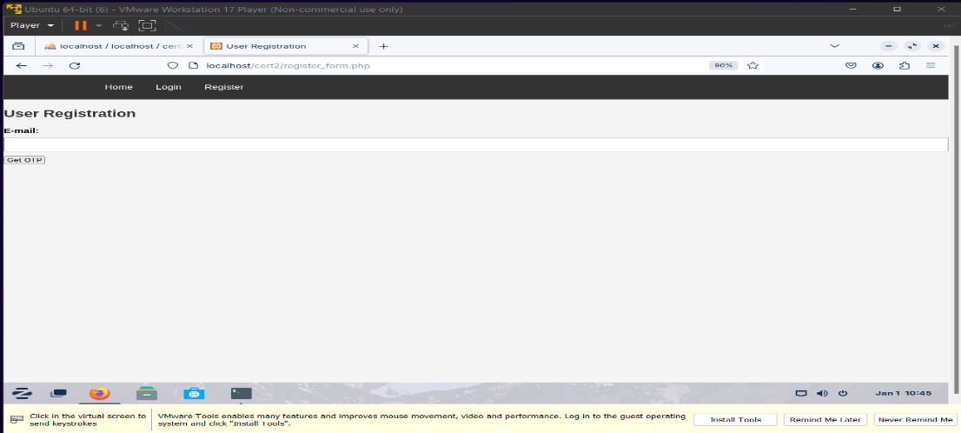

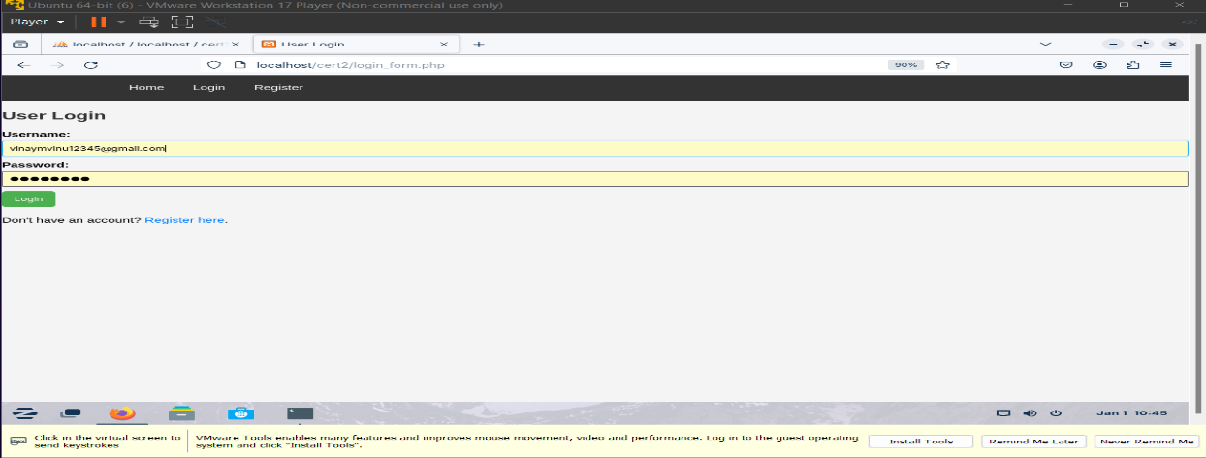

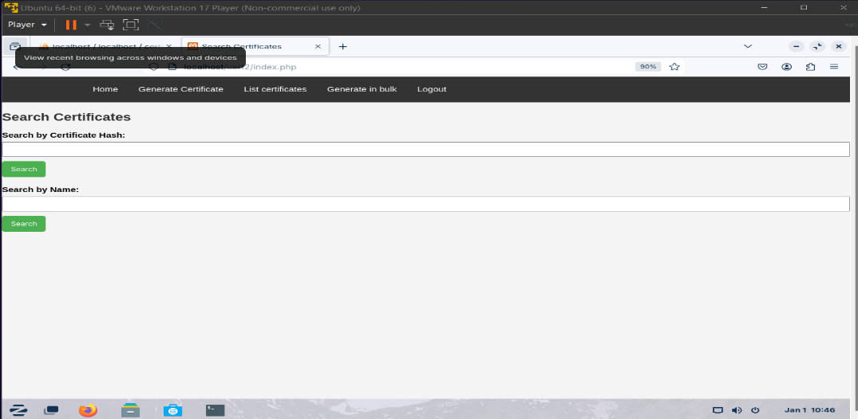**’**

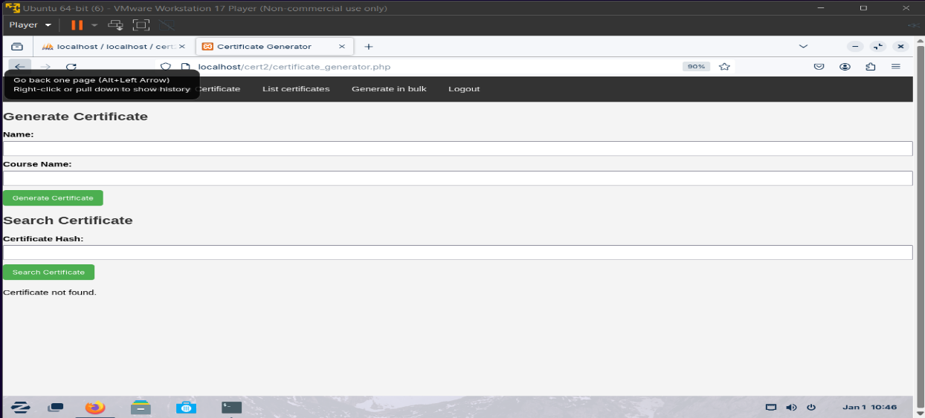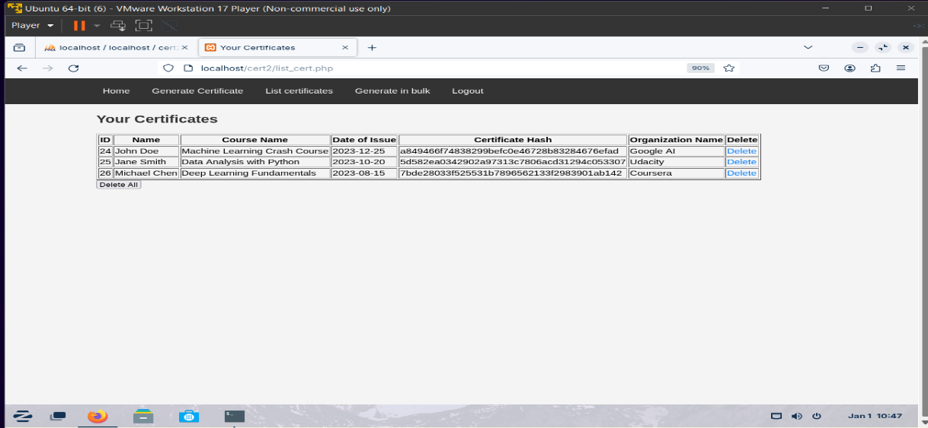

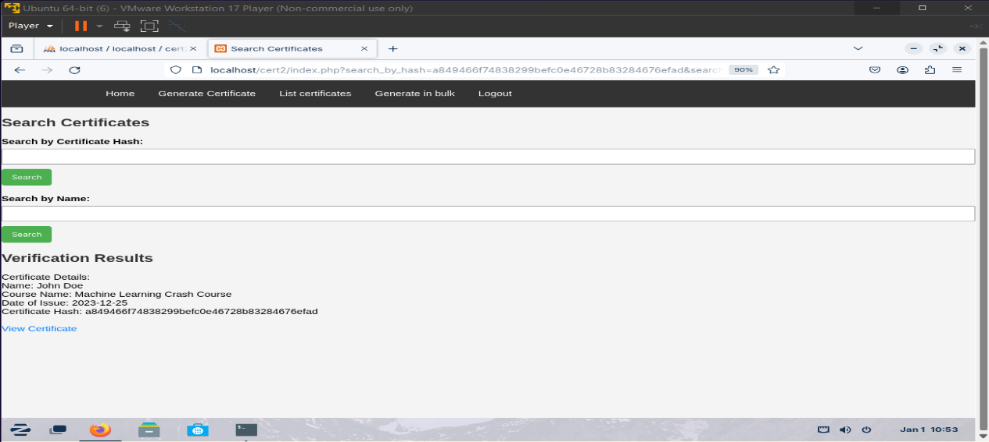

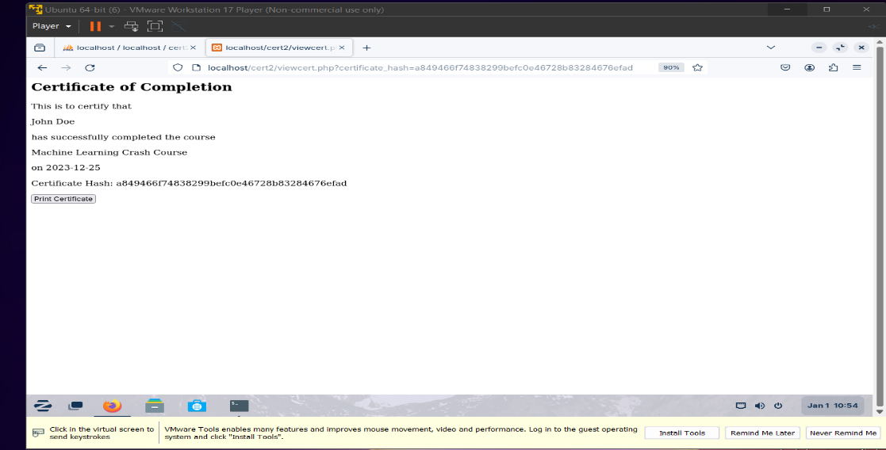



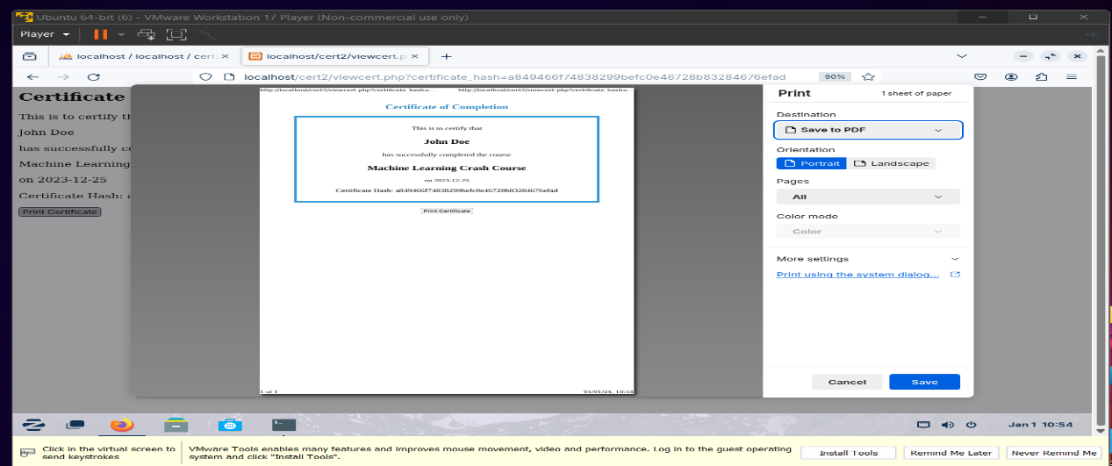

**APPENDIX-C**

**ENCLOSURES**

**Confirmation Letter of Publication Paper Form**

International Journal of Creative Research Thoughts

**Plagiarism Report**

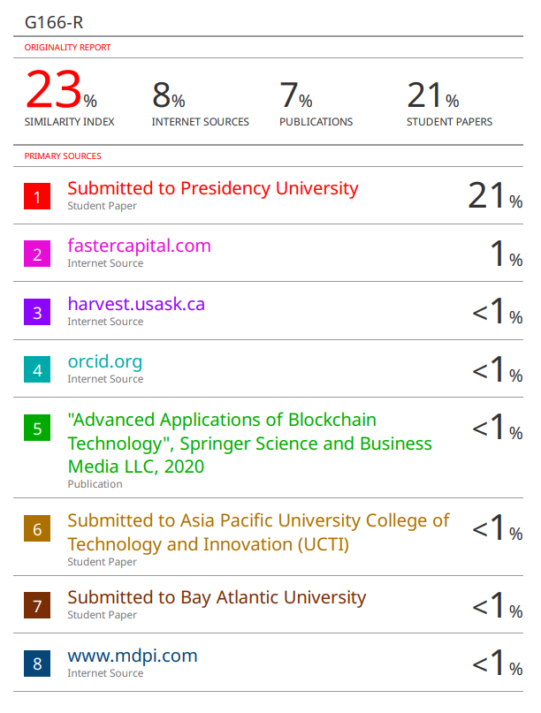

**Sustainable Development Goals**

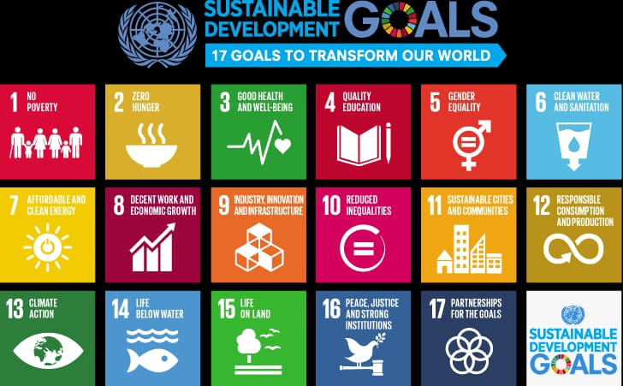

**The Project work carried out here is mapped to SDG-4**

**Quality Education.**

The project work carried out here promotes inclusive and equitable quality education by ensuring the authenticity of educational certificates, reducing fraud, and facilitating global recognition of qualifications. This contributes to building a more sustainable and accessible education system worldwide.